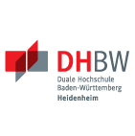
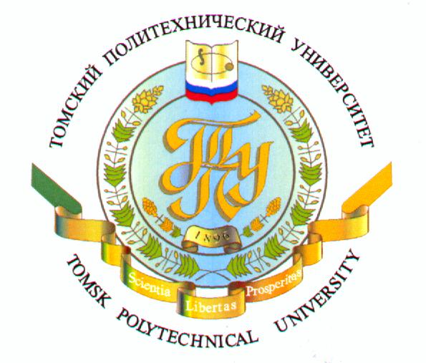

Summer School “Resource-efficient technologies:
Experience of Russia and Germany”

Sunday 15.06.14 | Arriving
Monday 16.06.14 | Block 1. Institute of High Technology Physics of TPU
9.30-13.00 | Opening of the workshop. Welcome speech. | Prof. Tatyana S. Petrovskaya Deputy Vice-Rector for Academic and International Affairs  Prof. Klaus-Dieter Rupp (DHBW)  PhD Oleg A. Aleksandrov Head of the Department of German Language
9.30-13.00 | “Technologies of water purification” | PhD Jakov I. Kornev Senior Research Scientist of Lab №12
14.00-17.00 | “Researches of nanomaterials within the NanoBRIDGE program” | Prof. Oleg L. Khasanov Head of the Department of Nanomaterials and Nanotechnologies
14.00-17.00 | Excursion to the Nanomaterials and Nanotechnologies Centre
Tuesday 17.06.14 | Block 2. Institute of Cybernetics of TPU
9.30-13.00 | “EAGLE - Enhanced Government Learning” | Prof. Möbs (DHBW)
9.30-13.00 | “The role of robotics and mechatronics in improvement of resource efficiency in industrial production” | PhD Vladislav A. Rudnitskij Associate professor of the Department of Integrated Computer Control Systems
9.30-13.00 | “Material (real, corporeal) interpolation method in automatic control” | Prof. Valerij I. Goncharov Department of Integrated Computer Control Systems
14.00-17.00 | Excursion to the Labs of the Institute of Cybernetics
Wednesday 18.06.14 | Block 3. Baden-Württemberg Cooperative State University
9.30-13.00 | “Design for Material Saving and sustainability” | Zsolt Roth Engineer of VOITH (DHBW)
14.00-17.00 | Excursion to the Special economic zone of Tomsk
Thursday 19.06.14 | Block 4. Baden-Württemberg Cooperative State University
9.30-13.00 | “Simulation of renewable energy Systems” | Prof. Klaus-Dieter Rupp (DHBW)
14.00-17.00 | Workshop “Requirements to project works” | Prof. Klaus-Dieter Rupp (DHBW)
14.00-17.00 | Excursion to the Tomsk Electromechanical Plant
20.06.14 – 22.06.14 | Excursion to the Krasnojarskaya hydroelectric station (additional charges)
Monday 23.06.14 | Block 5. Institute of Physics and Technology of TPU
9.30-13.00 | “Ion-plasma methods of biocoating deposition: problems and perspective” | Prof. Vladimir F. Pichugin Head of the Department of Theoretical and Experimental Physics
9.30-13.00 | “Hybrid materials for biomedical applications” | PhD Segrey I. Tverdohlebov Associate professor of the Department of Theoretical and Experimental Physics
14.00-17.00 | Excursion to the Labs of the Institute of Physics and Technology
Tuesday 24.06.14 | Block 6. Institute of Power Engineering of TPU
9.30-13.00 | “Modern aspects of energy saving in the field of power engineering” | Prof. Vasily Y. Ushakov Head of the Resource Saving Regional Centre
9.30-13.00 | “Problems of energy saving” | PhD Nikolay N. Kharlov Engineer of the Resource Saving Regional Centre
9.30-13.00 | “Development of heating schemes of cities with due account for promising energy-saving technologies” | PhD Irina P. Ozerova Head of the Department of Heat and Power Process Automation
14.00-17.00 | Excursion to the Labs of the Institute of Power Engineering
Wednesday 25.06.14 | Block 7. Institute of Non-Destructive Testing of TPU
9.30-13.00 | “Solution for water treatment and water purification” | Prof. Sergey V. Romanenko Head of the Department of Ecology and Basic Safety
9.30-13.00 | “Nanopowders of metals and chemical compounds produced by electrical explosion of conductors: properties and applications” | Prof. Olga B. Nazarenko Department of Ecology and Basic Safety
14.00-17.00 | Excursion to the Labs of the Institute of Non-Destructive Testing
Thursday 26.06.14 | Block 8. Institute of Natural Resources
9.30-13.00 | “Ecological-geochemical specifics of the environment and public health” | Prof. Leonid P. Rihvanov Department of Geoecology and Geochemistry
9.30-13.00 | “Complex usage of coals as resource base for high technologies” | Prof. Sergey I. Arbuzov, Department of Geoecology and Geochemistry
14.00-17.00 | Excursion to the Labs of the Institute of Natural Resources
Friday 27.06.14 | Final Block
9.30-13.00 | Final projects examination of students of TPU and DHBW | Prof. Klaus-Dieter Rupp (DHBW)
14.00-17.00 | Banquet
Saturday 28.06.14 | Picnic/Sightseeing
Sunday 29.06.14 | Departure

the summer school programme can be amended

