NATIONAL TECHNICAL UNIVERSITY OF UKRAINE  "KYIV POLYTECHNIC INSTITUTE" | 
TOMSK POLYTECHNIC UNIVERSITY | 
POLTAVA NATIONAL TECHNICAL YURI KONDRATYUK UNIVERSITY | 
POLTAVA UNIVERSITY OF ECONOMICS AND TRADE | 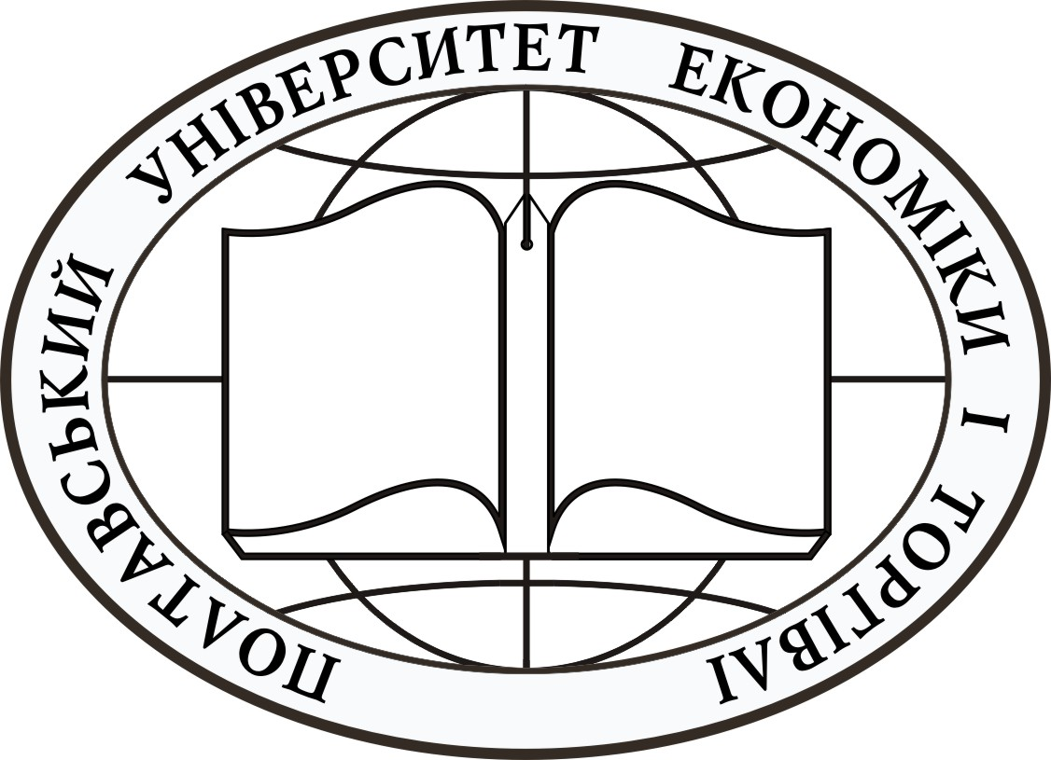
DEAR STUDENTS!
On 16 − 25 April 2013 the Internet English-Physics-Maths Competition 2013 will be held.
The first- and the second-year students are invited.

The Internet English-Physics-Maths Competition 2013 aims to encourage the study of English, Physics and Mathematics.
Participation in this competition will allow you to:
- test your knowledge with stimulating questions in English, Physics and Mathematics;
- compare your attainment with students from different universities;
- stimulate enthusiasm and love for competitions;
- acquire major strategies for problem solving;
- develop flexibility in solving problems;
- strengthen intuition;
- foster creativity and ingenuity;
- provide for the satisfaction, joy and thrill of meeting challenges;
- win certificates.
Language of the Competition is English.
English, Mathematics and Physics Tests will be suggested.
English tests include 4 sections:
- Listening Comprehension
- Structure and Written Expression
- Reading Comprehension
- Writing an essay
In the section "Listening Comprehension" you will hear two pieces of information with ten statements for each one. Then you will read the four possible answers (for each statement) and decide which one would be the best answer to the question. You need to mark your answer.
In the section "Reading Comprehension" you will read two passages. Each one is followed by ten questions about it. For the suggested questions you need to choose the one best answer (A), (B), (C), and (D), to each question. You have to answer all of the questions following a passage on the basis of what is stated or implied in that passage.
In the section "Structure and Written Expression" questions 1−40 are incomplete sentences. Beneath each sentence you will see four words or phrases, marked (A), (B), (C), and (D). You need to choose the one word or phrase that best completes the sentence.
In the section "Writing an essay" you have to write an essay on the base of the suggested situation.
Tests on Physics and Mathematics contain 10 exercises each one.
Requirements: it is forbidden to use additional information on such electronic devices as mobile phones, notebooks, etc. during the tests.
Registration: the deadline for enrollment is 30.03.2012, passwords for getting access to the tests will be sent.
Winners: the choice of winners depends on the quantity of scores.
For participation you have to:
- send your Application Form on the e-mail: fl_olimp@ukr.net (deadline: March 30, 2013);
- participate in the competition 16.04.2013 − 25.04.2013.

The Internet English-Physics-Maths Competition is run by 39 committee members from Ukraine and Russia (National technical university of Ukraine "Kyiv polytechnic institute", Tomsk Polytechnic University, Poltava national technical Yuri Kondratyuk university, Poltava university of economics and trade).
Organizing Committee
Teachers of English
Hanna Korsun | Alina Kotkovets
Iryna Simkova | Olena Dubinska
Oksana Synekop | Avagyan Svitlana
Hanna Tsyrkal | Svitlana Moskalenko
Olga Ameridze | Alla Feschuk
Iryna Kubrak | Tetiana Holub
Oleksiy Tsepkalo | Olga Pavlova
Anastasiia Gavryliuk | Olga Ivanova
OlenaYashchuk | Oksana Yarmolenko
Andrii Pavlovych | Yuliana Drobyazko
Tetiana Korol | Mariya Lebedeva
Volodymyr Stetsenko | Yuliya Gaidenko
Svitlana Iemets | Iryna Kozubska
Yana Dyachenko | Ganna Sokotun
Valentyna Strilets | Alla Koshlata
Anna Kravchenko | Natalia Drozdovych
Vera Verhoturova | Natal'ja Danejkina
Natal'ja Dem'janenko | Ol'ga Shajkina
Katеrina Karpacheva
Physics-Mathematics Teachers
- Helen Gomonay − Prof. of Information Security Chair, Institute for Physcis & Technology
- Andrii Ilienko − Candidate of Physical and Mathematical Sciences, Associate Professor of the Department of Mathematical Analysis and Probability Theory
The administrative office is situated at:
Faculty of Linguistics, NTUU "KPI"
For enquiries please contact 096 245 51 35 / 406-85-37 kamts2@ukr.net
Address Site:
http://fl.kpi.ua
http://kamts2.fl.kpi.ua
http://kamgs3.fl.kpi.ua
http://www.im.uccu.org.ua
http://www.pntu.edu.ua
http://today.tpu.ru/tpu-structure/instituty-fakultety-kafedry/fti/mkpiya/index.html

TAKE THE CHALLENGE!

