HyperText Markup Language (HTML)
Before you start creating templates for real web sites, you have to make two HTML-documents using the knowledge obtained at the lectures. Without using cascading style sheets. Thus, you will consolidate knowledge of the knowledge of HTML tags and will be able to apply them more confidently in subsequent lab work. This methodological instruction describes tasks for creating an HTML document.
Appendix A consists of a fragment of a formatted document. You are encouraged to makeup this fragment using the hypertext markup language. As a result, you should get an HTML document that is identical to the fragment. Note that the text written in square brackets is not necessary to transfer to the HTML document - this is an explanation). In order to proceed with the performance of laboratory work:
- Create an empty text document using notepad++ or IDE PHPStorm.
- Set syntax highlight in the notepad++ as shown on figure 1. The IDE PHPStorm will highlight syntax automatically.
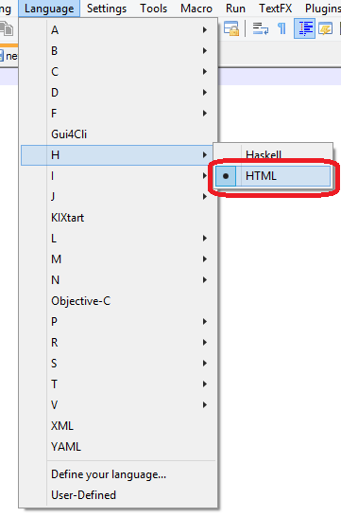
Figure 1 – HTML syntax highlight settings in the notepad++
- Makeup HTML document as shown in appendix A. Open this document in two browsers (Internet Explorer (EDGE) and Google Chrome) to look to the result.
- The laboratory work is considered complete if the document looks the same as shown in appendix A in both browsers.

Appendix A
The list of indicators [a header 2]
An expert must follow the rules while completing the list of indicators: [a paragraph with indent, line spacing 1.5]
- be careful;
- objectively evaluate each participant;
- the maximum mark is 10. [a list with roman numerals]
Table 1. The list of indicators table [The table has a bold borders. Participant names should be assigned in a center of cells (vertically and horizontally). The current year must be underlined. Incorrect mark values should have red font]
Criteria | Participant 1 |  | Participant 2 |  | Participant 3
 | 2016 | 2017 | 2016 | 2017 | 2016 | 2017
Criteria 1 | 8 | 4 | – | 6
Criteria 2 | 8 | 2 | 8 | 2
Criteria 3 | 7 | 1 | 6 | 8
Criteria 4 | 1 | 12 | 5 | 5
Criteria 5 | 4 | 3 | 5 | 5
Below is a list of participants with the total points for the past year [multilevel bulleted list]
- Participant 1:
  - 130 points at 2014 year
  - 143 points at 2013 year
- Participant 2:
  - 130 points at 2014 year
  - 130 points at 2013 year
- Participant 3:
  - 130 points at 2014 year
  - 130 points at 2013 year
You need to register here [a link to the next HTML document] in order to proceed with the participant`s evaluation.

