PLOTTING AND ANALYSIS OF THE HYDROGEOLOGICAL CROSS SECTION
Objective: to get acquainted with the principles of plotting and analysis of hydrogeological cross sections.
Hydrogeological cross sections (profiles) – a form of graphic processing and generalization of hydrogeological information. They characterize the hydrogeological conditions of the territory in the vertical section, complement the maps or have an independent value. In the first case, their scale and content are determined by the scale and content of the map, in the second - by the purpose of the work.
Analysis of the hydrogeological cross section
The hydrogeological cross section is analyzed in the following order:
- Establish aquifers and aquitards, the conditions of their occurrence, the composition of permeable and impermeable rocks and data on the levels of groundwater and surface water.
- Determine the thickness of the water-bearing layers and impermeable layers (the difference in the marks of top and bottom), thickness of aquifers (thickness of free-surface aquifers differ from head-water aquifers), depth of the aquifer occurrence (the difference between the marks of the earth’s surface and the top of the water-bearing layer); pressure above the top of aquifers (the difference in marks between the piezometric level (standing head water level) and the top of the head-water aquifer). Determine the thickness and structure of the vadose zone, which is important for assessing the infiltration recharge of groundwater; establish the presence of impermeable layers in the vadose zone, since they can form a temporary perched groundwater, also it leads to possibility of the formation of local pressure zones.
- Characterize the conditions of groundwater flow: the direction of flow, the hydraulic slope of the flow in different areas, the relationship with surface watercourses (see additional information).
- Identify the conditions of recharge and discharge of groundwater, the location of areas of recharge and discharge. Note the areas of water access to the earth’s surface (erosive type of discharge), in the zone of tectonic faults (barrier springs), areas of erosion "windows" of impermeable strata. Discharge to rivers, seas forms closed (hidden) zones of discharge. With a shallow groundwater table, discharge by evaporation and transpiration from their groundwater table is observed. Shallow groundwater recharge usually occurs in the whole area of ​​their development by infiltration of atmospheric precipitation through the vadose zone, as well as infiltration from rivers, lakes, canals, adjacent aquifers.
- Establish the nature and intensity of the relationship between aquifers from the lithological-facial analysis of the cross section and the relationships between the heads of adjacent aquifers, the nature of the variation of the heads in the cross section.
- The factors that protect aquifers from pollution are called.

Additional information.
The relationship between the groundwater table and the relief.
The groundwater table, as shown by hydrogeological surveys of large areas, mostly uneven, wavy. Often it repeats the relief of the earth's surface in a smoothened form (Fig. 1), but in certain areas for various local reasons, for example, due to drainage of the groundwater flow by the river, a sharp increase in the thickness of the aquifer, etc., this relation between the earth’s surface and groundwater table may be broken.
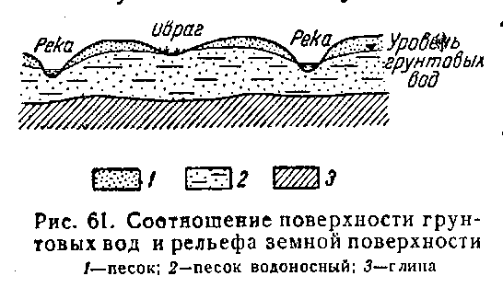
The depth of groundwater from the surface is different; often it depends on the relief. In river valleys, ravine and other depressions, the groundwater table lies at a comparatively shallow depth and at the intersection of the groundwater table by the earth’s surface groundwater access to the earth’s surface. As the elevation increases, the depth of the groundwater table increases; on watersheds, hills and other hills, it can reach several tens of meters. At the same time, absolute elevation of groundwater levels in elevated areas are higher than in depressions, so groundwater flow, with rare exceptions, is directed from elevations to depressions.
Fig. 3. Relationship between groundwater table and relief of the earth’s surface: 1 – sand, 2 – water-bearing sand, 3 – clay.
Relation of the groundwater with surface water bodies.
Shallow groundwater usually has a hydraulic connection with the waters of surface water bodies (rivers, lakes, ponds, etc.). River valleys can be composed of alluvial or in some regions fluvioglacial deposits, represented by sands and coarser sand-gravel material. In these deposits, there is areas contained abundant groundwater of high quality.
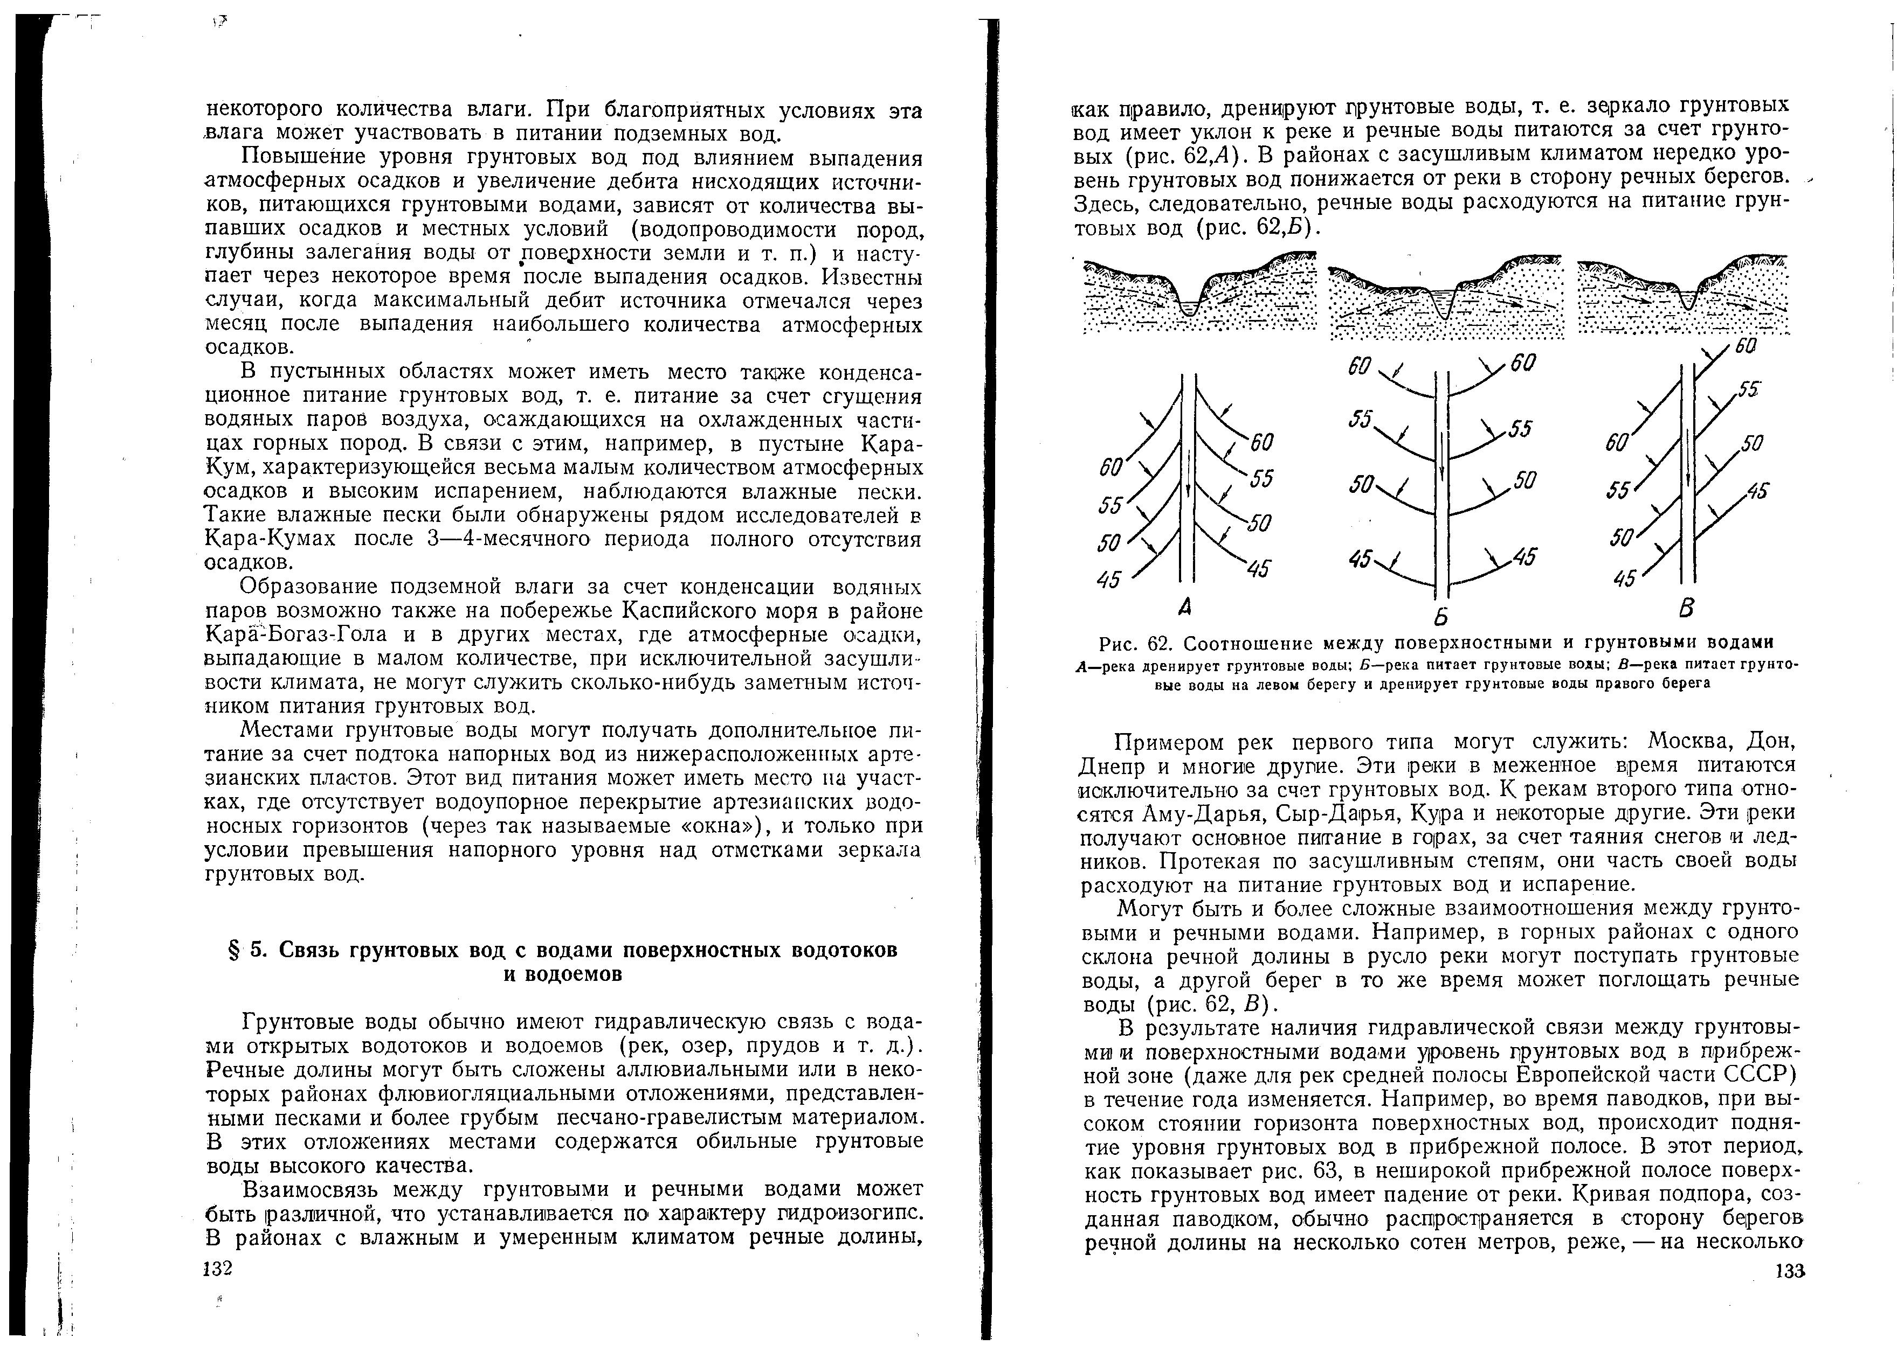
The relationship between groundwater and river water can be different, which is determined by the isohypes of stable water level. In areas with a humid and temperate climate, river valleys tend to drain groundwater, i.e. the groundwater table has a slope to the river and the river water is fed by groundwater (Fig. 2, А). In areas with an arid climate, the groundwater table often falls from the river towards the river banks. Here, therefore, river water feeds groundwater (Fig. 2, Б)
Fig. 2. Relation of the groundwater with surface water bodies. А – the river drains groundwater, Б – the river feeds the groundwater, В – the river feeds groundwater on the left bank and drains groundwater on the right bank.
There may also be more complex relationships between groundwater and river. For example, in mountainous areas from one slope of the river valley, groundwater can flow toward the river bed, while river water from the other bank can infiltrates to the aquifer (Fig. 2, В).

The task:
1. Complete the hydrogeological cross section (Appendix 1).
2. Mark the water levels in accordance with Table 1 in the wells and conduct groundwater levels (indicate the absolute elevation of the groundwater level next to each well).
3. Draw a legend.
4. Describe the hydrogeological setting.
Table 1
Initial data for the task
Well number | Absolute elevation, m
Well number | well head | appearance of groundwater during drilling | stable groundwater level
1 | 199,5 | 195,5 | 195,5
1 | 199,5 | 179,0 | 184,0
2 | 195,5 | 194,0 | 194,0
2 | 195,5 | 180,0 | 183,0
Stream | 193,5
3 | 197,5 | 194,5 | 194,5
3 | 197,5 | 182,5 | 182,5
4 | 192,0 | 190,5 | 190,5
4 | 192,0 | 181,5 | 181,5
Spring 9 | 189,5 | — | —
5 | 183,0 | 181,0 | 181,0
6 | 180,7 | 179,0 | 179,0
River Kozlovka | 177,5
Spring 10 | 188,0 | — | —
7 | 201,0 | 188,5 | 188,5
7 | 201,0 | 176,5 | 176,5
8 | 200,0 | 189,0 | 189,0
8 | 200,0 | 175,5 | 175,5

Appendix 1
Schematic hydrogeological cross section
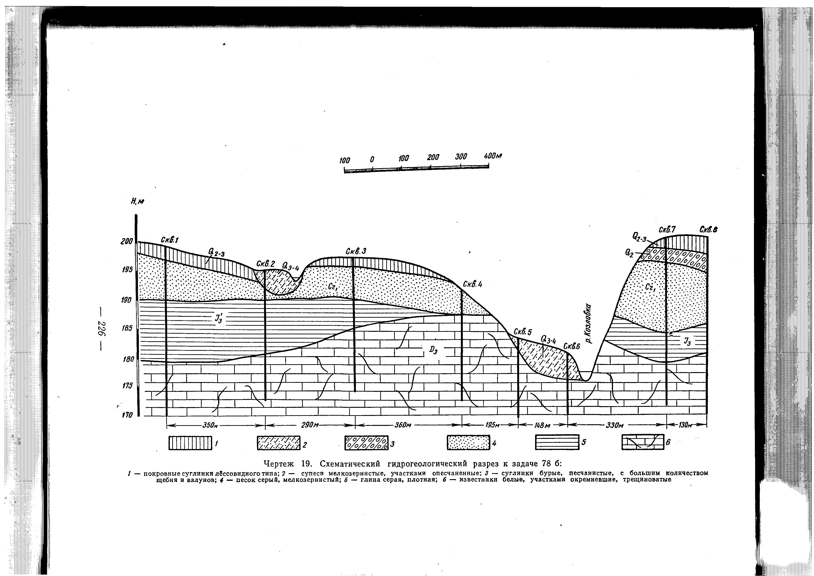
К₁
К₁

covering loam
Horizontal scale 1:10000, vertical scale 1:500
покровные суглинки
fine-grained sandy loam

супеси мелкозернистые, участками опесчаненные

brown loam with a lot of rubbles and boulders

суглинки бурые, песчанистые, с большим количеством щебня и валунов
gray fine-grained sand

песок серый, мелкозернистый
глина серая, плотная
gray heavy clay
известняки белые, участками окремневшие, трещиноватые
white fractured limestones, locally silicified

