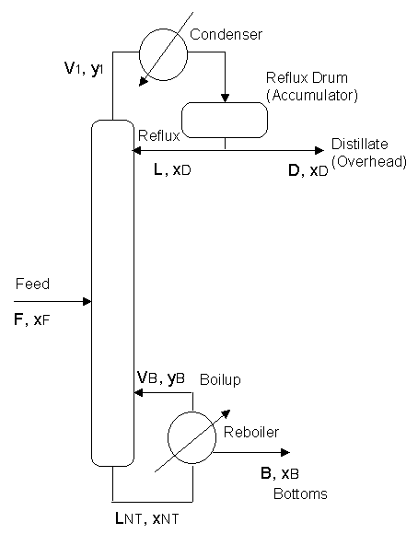

Distillation I: Principles

Definition & Purpose:
Distillation is the most widely used separation process in the chemical industry. It is also known as fractional distillation or fractionation. It is normally used to separate liquid mixtures into two or more vapor or liquid products with different compositions.
Distillation is an equilibrium stage operation. In each stage, a vapor phase is contacted with a liquid phase and mass is from vapor to liquid and from liquid to vapor. The less volatile, "heavy" or "high boiling", components concentrate in the liquid phase; the more volatile, "light", components concentrate in the vapor. By using multiple stages in series with recycle, separation can be accomplished.

Operating Principles:
The feed to a distillation column may be liquid, vapor, or a liquid-vapor mixture. It may enter at any point in the column, although the optimal feed tray location should be determined and used. More than one stream may be fed to the system, and more than one product may be drawn.
A column is divided into a series of stages. These correspond to a cascade of equilibrium stages. Liquid flows down the column from stage to stage and is contacted by vapor flowing upward.
Traditionally, most columns have been built from a set of distinct "trays" or "plates", so these terms end up being essentially interchangeable with "stages". Each tray in a distillation column is designed to promote contact between the vapor and liquid on the stage. Distillation can be conducted in a packed column (just as absorption can be done in a trayed column), but we will focus on trayed columns for the present.
Stages may be numbered from top down or bottom up. When analyzing a stage, flows and compositions take the number of the stage they leave. The text for this class calls the top tray of the column "Tray 1" and numbers downward.
The product leaving the top of the column is called the overhead product, the "overhead", the "top product", the distillate, or "distillate product". Distillate product may be liquid or vapor (or occasionally both) depending on the type of condenser used. Most of the time the distillate flow rate is assigned the symbol D, and the composition x_{D} or y_{D}.
The product leaving the bottom of the column is called the bottom product or "bottoms", and given the symbol B, with composition x_{B}.
In some situations, notably petroleum refining, one or more intermediate or "sidedraw" products may be removed from the column.
Vapor leaving the top of the column passes through a heat exchanger, the condenser, where it is partially or totally condensed. The liquid which results is temporarily held in the "accumulator" or reflux drum. A liquid stream is withdrawn from the drum and returned to the top tray of the column as reflux (R or L) to promote separation.
The portion of the column above the feed tray is called the rectification section. In this section, the vapor is enriched by contact with the reflux.
The portion of the column below the feed tray is called the stripping section. The liquid portion of the feed serves as the reflux for this section.
The operating pressure of the column is typically controlled by adjusting heat removal in the condenser.
The base of the column is typically used as a reservoir to hold liquid leaving the bottom tray. A heat exchanger, the reboiler, is used to boil this liquid. The vapor which results, the "boilup" (V) is returned to the column on one of the bottom three or four trays.
In normal operation, there are five "handles" that can be adjusted to manipulate the behavior of a distillation column -- the feed flow, two product flows, the reflux flow, and the boilup flow (or reboiler heat input).
A normal column has a temperature gradient and a pressure gradient from bottom to top.

Ideal Stages
Stages are built to maximize contact between the incoming vapor and the incoming liquid. During the contact, some of the liqht component in the entering liquid is vaporized and leaves with the vapor; some of the heavy component in the entering vapor condenses and leaves with the liquid.
By definition, an ideal stage is one where the vapor and liquid leave the stage in equilibrium. Consequently, the vapor composition functionally depends on the liquid composition. Ideality is an approximation, but stage efficiencies can be used to account for real cases. A key result of the ideal stage assumption is that liquid streams leaving an ideal stage are assumed to be at their bubble point. Vapor streams leave at their dew point.
When no azeotropes are present, both top and bottom products may be obtained in any desired purity --- if enough stages are provided and enough reflux is available. In practice, there are limits to the number of stages and to the amount of reflux, so not every separation can be accomplished. Theoretical limits on performance are imposed by total reflux (minimum stages) and minimum reflux (infinite number of ideal stages).
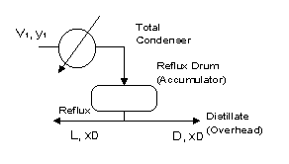
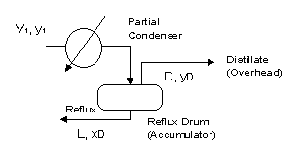

Condensers & Reboilers
There are two main categories of condenser, differentiated by the extent of condensation.
In a total condenser, all of the vapor leaving the top of the column is condensed. Consequently, the composition of the vapor leaving the top tray y₁ is the same as that of the liquid distillate product and reflux, x_{D}.
In a partial condenser, the vapor is only partially liquefied. The liquid produced is returned to the column as liquid, and a vapor product stream is removed. The compositions of these three streams (V₁, D, and R) are different. Normally, D (composition y_{D}) is in equilibrium with R (composition x_{D}).
A partial condenser functions as an equilibrium separation stage, so columns with a partial condenser effectively have an extra ideal stage.
The "reflux ratio" is an important parameter in column operation. It is normally defined as the ratio of reflux to distillate (L/D), although other formulations (L/L+D, etc.) are occasionally used.
Most reboilers are partial reboilers, that is they only vaporize part of the liquid in the column base. Partial reboilers also provide an ideal separation stage.
Reboilers take several forms: they may be "thermosiphon" types that rely on the thermal effects on density to draw liquid through the heat exchanger, "forced circulation" types that use a pump to force liquid through, or even "stab-in" types that come through the side of the column into the liquid reservoir.
In large, complex columns, sidestream reboilers can be used. These draw liquid off a tray, heat it, and then return the vapor liquid mixture to the same or a similar trays.

Feed Condition
The thermal condition of the feed determines the column internal flows.
If the feed is below its bubble point, heat is needed to raise it to where it can be vaporized. This heat must be obtained by condensing vapor rising through the column, so the liquid flow moving down the column increases by the entire amount of the feed plus the condensed material and the vapor flow upward is decreased.
If the feed enters as superheated vapor, it will vaporize some of the liquid to equalize the enthalpy. In this case, the liquid flow down the column drops and the vapor flow up is increased by the entire amount of the feed plus the vaporized material.
If the feed is saturated (liquid or vapor), no additional heat must be added or subtracted, and the feed adds directly to the liquid or vapor flow.

References:
- Foust, A.S. et al., Principles of Unit Operations, 2nd Edition, John Wiley, 1980, pp. 13-14.
- McCabe, W.L., J.C. Smith, P. Harriott, Unit Operations of Chemical Engineering, 5th Edition, McGraw-Hill, 1993.

R.M. Price
Original: March 1997
Modified: 14 April 1998; 13 February 2003
Copyright 1997, 1998, 2003 by R.M. Price -- All Rights Reserved

