Useful Phrases for FCE Speaking Part 2 - the Long Turn
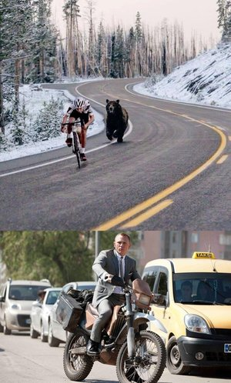
Here are some useful phrases you can use in part 2 of the FCE speaking test. I've also written some example sentences so you can see how to use them properly. All my example sentences are based on these photos.

The top picture shows...
The bottom picture shows...
[The top picture shows a man riding a bicycle, while the bottom picture shows a man riding a motorbike.]
In one photo there are...
In the other photo there are...
[In one photo there are some wonderful, snow-covered trees while in the other photo there are cars in the background.]
In the picture above it looks as if...
In the one below it looks like...
[In the picture above it looks as if a bear is chasing the man while in the one below it looks like the man is chasing somebody else.]
Both pictures show...
In both pictures there are...
They're both quite similar because they both show...
[Both pictures show men traveling on their own.]
There are... in both photographs.
[There are men riding alone in both photographs.]
This picture shows... but that one...
[This one shows a cold country but that one looks quite hot.]
In one respect the pictures are quite similar because...
[In one respect the pictures are quite similar because the men look very fit and sporty.]
One difference between the pictures is that...
[One difference between the pictures is that we can see other cars and people in this picture.]
The biggest difference between them is that this one... but the other one...
[The biggest difference between them is that this one has a bear in it but the other one doesn't have any bears.]
This one looks more ... than that.
[This one looks more fun than that.]
Doing ... isn't so ... as...
[Riding a motorbike in a busy city isn't so healthy as riding a bike in the fresh air.]
In my opinion...
I'd say that...
I think...
It seems to me...
My view is that...
[My view is that this bear has been photoshopped into that picture. There's no way that's a real picture. It seems to me that the maker of FCE Exam Tips tried to make this more interesting by putting a bear in the photo.]
Another thing that's different is...
Something else that's different is...
[This is a cold place, whereas this place looks hot. Another thing that's different is that this motorbike looks quite old and cheap, while the bike seems quite expensive.]
They're alike in another way, too.
[Both men look strong and healthy. They're alike in another way, too - they are both adventurous and don't mind traveling alone.]

