Technical Specifications for FDM
Standard lead time | Minimum of 4 working days (or 48 hours for models using the Fast Lane service), depending on part size, number of components and finishing degrees
Standard accuracy | ± 0.15% (with lower limit on ± 0.2 mm)
Layer thickness | 0.18 – 0.25 mm (varies depending on the chosen material)
Minimum wall thickness | 1 mm
Maximum build dimensions | Dimensions are unlimited as components may be composed of several sub-parts. The maximum build envelope is 914 x 610 x 914 mm
Surface structure | Unfinished parts typically have a rough surface but all kinds of fine finishes are possible. FDM parts can be sandblasted, smoothed, coloured/impregnated, painted and coated

Materials for FDM
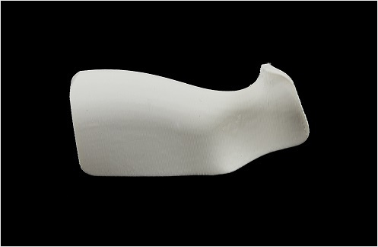

ABS (Acrylonitrile Butadiene Styrene)
ABS is a widely used engineering thermoplastic with high durability and fine feature detail. Printed ABS has up to 80% of the strength of injection-molded ABS, making it highly suitable for functional applications. This material is opaque and available in several color options. Applications include snap-fits, end-use components, jigs and fixtures, concept modeling, and testing for form, fit and function.

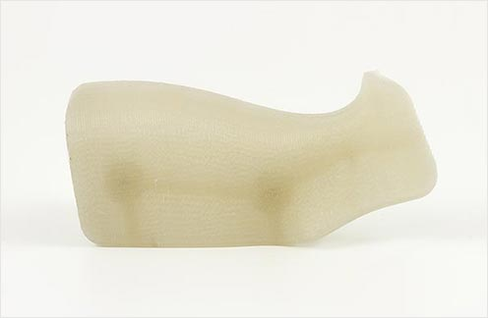
ABSi (Acrylonitrile Butadiene Styrene – Biocompatible)
ABSi is an ABS type thermoplastic with high impact strength. This material is stiffer and more durable than the standard ABS material, and appears translucent. That makes ABSi ideal for applications which require light transmission or flow monitoring, such as in the automotive industry or for medical device prototyping. The ABSi material used in FDM is USP Class VI approved, a standard related to the pharmaceutical and biotechnology industries.

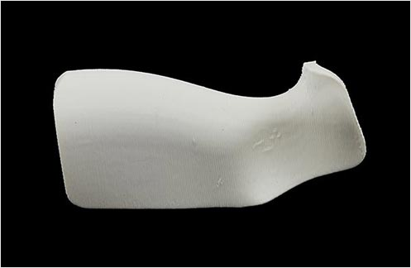

ABS-M30 (Acrylonitrile Butadiene Styrene)
ABS-M30 is 25-75% stronger than the standard ABS material, with higher durability, ideal for realistic functional tests. This material results in smoother parts with finer feature details. ABS-M30 is opaque and is available in several color options. Ideal applications, similar to those of ABS, include end-use components, jigs and fixtures, concept modeling, and testing for form, fit and function.

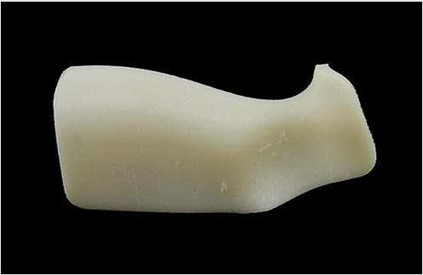
ABS-M30i (Acrylonitrile Butadiene Styrene – Biocompatible)
Similar to ABS-M30 in its high strength, durability and fine feature detail, ABS-M30i is additionally biocompatible in its raw state and complies with ISO 10993. With these material properties, the material is suited for end-use components as well as form, fit and function testing. Its biocompatibility certification makes ABS-M30i ideal for applications in food and drug packaging, and the medical devices industry.

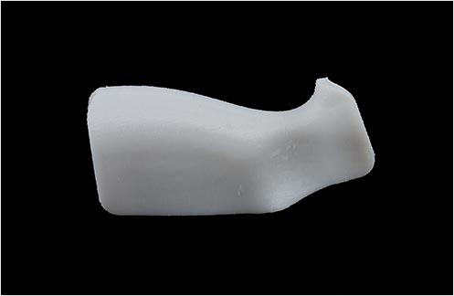

PC (Polycarbonate)
Polycarbonates (PC) are among the most widely used industrial thermoplastics owing to the material’s excellent impact strength and temperature resistance. The mechanical properties of PC make this material ideal for demanding engineering environments or applications requiring high flexural strength and tensile strength.

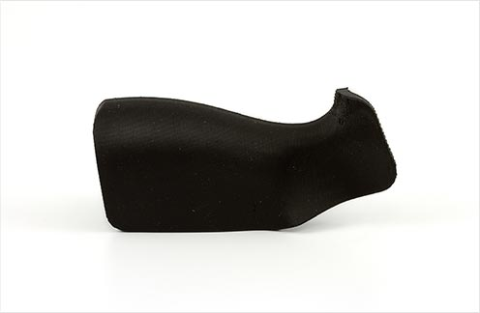

ABS-ESD7 (Acrylonitrile Butadiene Styrene – Static-Dissipative)
ABS-ESD7 is a durable and electrostatic-dissipative material. The static-dissipative property makes ABS-ESD7 particularly suitable for applications where a static charge could impair performance, such as electronic products with circuit boards. Other applications for this material include end-use components, industrial equipment and jigs and fixtures for the assembly of electronic components.

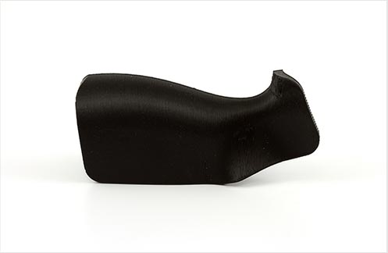

PC-ABS (Polycarbonate ABS)
PC-ABS is a blend of polycarbonate and ABS plastic which combines the strength and heat resistance of PC with the flexibility of ABS. PC-ABS exhibits high impact strength and thermal resistance, making this material an ideal choice for demanding engineering environments. Applications include snap-fits, end-use components, jigs and fixtures, concept modeling, and testing for form, fit and function.

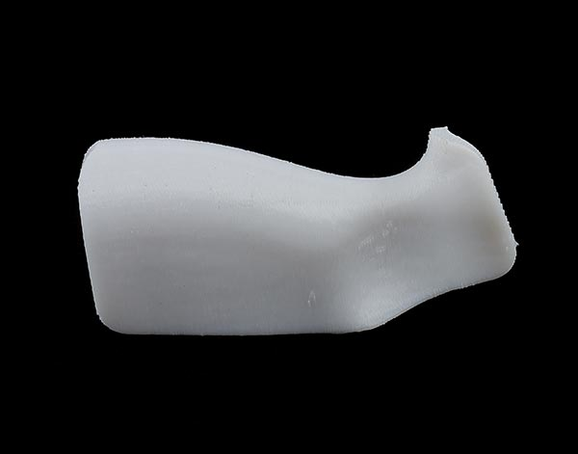
PC-ISO (Polycarbonate ISO)
PC-ISO blends have high impact strength, thermal resistance and durability. This industrial thermoplastic is widely used throughout packaging and medical device manufacturing because of its strength and health standards. The PC-ISO material used to build FDM parts is biocompatible in its raw state, being USP Class VI approved and also ISO 10993-1 rated.

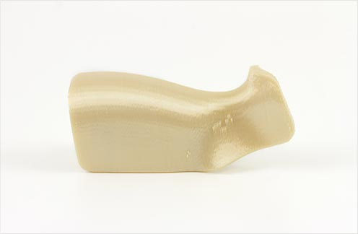

Ultem 9085
Ultem 9085 is a pioneering thermoplastic that is strong, lightweight and flame-retardant (UL 94-V0 rated). With its superior mechanical performance and strength-to-weight ratio, Ultem 9085 is suitable for end-use production-grade components, particularly in the aerospace and automotive industries. Other applications including highly functional prototypes and production tools.

