Tomsk Polytechnic University

PHYSICS I
Laboratory Guide.

Tomsk 2000

PHYSICS I
Methodical Instructions in General Physics Laboratory Practice Work for Students of all Specialization.

The Methodical Instructions have been discussed and approved by the Methodical Council of the Theoretical and Experimental Physics Department.

Authors: V. M. Antonov
N. S. Kravchenko

V. F. Pichugin

N. I. Gavrilina

Evaluation of Errors

Physics is said to be a science of measurements. To measure a physical quantity, it is necessary to compare it with a well-known standard. In the process of comparison we make errors. Errors are caused by inaccuracy of experimental equipment and measuring procedure. It is useless to speak about absolutely accurate measurements. One can only speak about the interval of probable values of the physical quantity under investigation. The theory of measurements deals with a problem how to choose an adequate method of measurements and to evaluate the experimental errors.
All kinds of measurements are known to be subdivided into two groups: direct and indirect measurements. If a physical quantity is being measured directly with a measuring device, these measurements are called direct measurements. For example, you can measure a distance with a ruler, a thickness with a micrometer, a time with a watch, and an electric current with an amperemeter. But in many applications a physical quantity y to be measured depends on other quantities x₁, x₂,… which are measured directly, i.e.,
y = f(x₁,x₂,…) (1.1)
Thus, the value of y is to be calculated. To measure the speed of a body v=S/t, you are to measure the distance S and the time t needed for the body to cover this distance and then to divide S by t. The measurements of such kind are called indirect measurements, and sometimes they are rather complicated.
All the errors made in an experiment can be subdivided into three groups: crude (gross), systematic, and random errors. Crude errors may arise because of some unexpected external influence, inadequate experimental procedures, and so on. While analyzing the experimental data, such errors should not be taken into account and measurements should be repeated.
Systematic errors are the errors which have the same sign and value and are repeated during the experiment. The errors of this kind can be eliminated while making calculations.
Random errors are caused by a great number of factors which are very difficult to consider. They may arise when conditions of the experiment do not change. They are small but inevitable. For example, they may be caused by random vibrations of experimental devices, random variations in external electromagnetic fields, mechanical friction, temperature variations, and so on. The theory of random errors is well elaborated and permits their influence on experimental results to be evaluated. The art of an investigator consists in his ability to distinguish between systematic and random errors.
Let us denote a random variable by x and its true value by $\bar{x}$. According to the theory of probabilities, $\bar{x}$ is called the mathematical expectation. The quantity
$Δx=x−\bar{x}$ (1.2)
is called the deviation (i.e., the error).
For a random quantity we cannot find a true value; we can only determine an interval where it must be located and we can indicate the probability of finding it in this interval. To calculate this probability, an expression for the probability density was derived by Gauss. This expression is the Gauss distribution which is very often called the normal distribution
$f(x)=\frac{1}{\sqrt{2π}⋅σ}e^{−\frac{(x−\bar{x})^{2}}{2σ^{2}}}$. (1.3)
Here, σ is called the standard deviation and σ² is the variance of the random quantity x. The function f(x) is shown in Figure 1.
The quantity

$\text{dp}=f(x)\text{dx}$ (1.4)

is the probability that the value x lies in the interval from x to x + dx. Obviously,

$\int_{(x)}{f(x)\text{dx}}=1$. (1.5)

Figure 1. The value of σ characterizes the width of the distribution function. The greater σ, the wider is the distribution function.
The Gauss law was derived under the following assumptions:
- The values of x are continuos.
- Negative and positive deviations Δx have the same probability.
- The larger the deviation Δx, the lower is its probability.
The random variables having these properties are called normal.
For the majority of physical quantities, the Gauss distribution holds very well.
The quantities x and σ are called the parameters of the Gauss distribution. In practical applications these parameters are unfortunately unknown and some estimates should be used. The best estimate for the mathematical expectation is the arithmetic mean, i.e.,
$\tilde{x}=\frac{\sum{x_{i}}}{n}$ , (1.6)
where n is the number of measurements and x_{i} is a specific value of x in the ith measurement. In the theory of errors, it is also shown that the best estimate for the standard deviation can be represented as follows:
$σ=\sqrt{\frac{\sum{(\tilde{x}−x_{i})^{2}}}{n(n−1)}}$. (1.7)
The degree of proximity between $\tilde{x}$ and $\bar{x}$ can be characterized by the confidence interval $Δ\tilde{x}$ within which the error modulus will lie with a sufficiently high confidence probability α, i.e.,
$p\left\{\left|x−\tilde{x}\right|≤Δ\tilde{x}\right\}=α$. (1.8)
In other words, this is a statement that with a probability α, the true value $\bar{x}$ lies in the interval $\tilde{x}±Δ\tilde{x}$ (see Figure 2).
A method for numerical evaluating the confidence interval was developed by W. S. Gosset.
Here we give only a practical implementation of this method.

- Having measured individual values of x, we need to determine $\tilde{x}$.

- The total error is considered to
consist of two parts: Δx_{i} is an error in Figure 2. individual measurement and Δx_{a} is random error, which are summed geometrically
$Δ\tilde{x}=\sqrt{{Δx}_{i}^{2}+{Δx}_{a}^{2}}$. (1.9)
Usually, half the device accuracy is chosen as an individual error.
- The random error is calculated in accordance with the relation
${Δx}_{a}=t_{α,n}\sqrt{\frac{\sum{(\tilde{x}−x_{i})^{2}}}{n(n−1)}}$, (1.10)
where the quantities t_{α,n} are called Student’s coefficients. They depend on the confidence probability α and the number of measurements (usually n = 3 − 5). The values of t_{α,n} are tabulated. As a rule, α is chosen to be 0.95; then, for example, t_{α,3} = 4.3 and t_{α,5} = 2.78.
- The value of $Δ\tilde{x}$ should be rounded off, and the value of x should be given with accuracy corresponding to that of the error. The result cannot have more significant digits than the initial measurements. For example, v = (320 ± 10) m/s, or g = (9.812 ± 0.007) m/s².
In general the quantity to be determined depends on several variables
$y=f(x_{1},x_{2},\text{.}\text{.}\text{.})$ (1.11)
Note: In the above relation, x_{i} are independent variables whose errors should be evaluated in accordance with items 1 − 4.
According to the theory of probabilities, y can be expressed as follows:
, (1.12)
and the confidence interval $Δ\tilde{y}$ can be represented in the form
$Δy=\sqrt{\sum{(\frac{∂f}{∂{\tilde{x}}_{i}})^{2}Δ{\tilde{x}}_{i}^{2}}}$ , (1.13)
where $\frac{∂f}{∂{\tilde{x}}_{i}}$ are the partial derivatives with respect to ${\tilde{x}}_{i}$, and Δx_{i} are the confidence intervals. When the function f(x₁, x₂,…) is rather complicated, it is more convenient to rewrite Eq. (1.13) in the form
$Δ\tilde{y}=\tilde{y}\sqrt{\sum{(\frac{∂\text{ln}y}{∂{\tilde{x}}_{i}})^{2}Δ{\tilde{x}}_{i}^{2}}}$. (1.14)
A very simple but efficient method of evaluating the error in indirect measurements is often used. The values of x_{i} are varied (and can be measured only once). Then the values of y_{i} are calculated for each run. The result is
$y=\tilde{y}±Δ\tilde{y}$, (1.15)
where
$\tilde{y}=\frac{\sum{y_{i}}}{n}$ (1.16)
and
$Δ\tilde{y}=t_{α,n}\sqrt{\frac{\sum{(\tilde{y}−y_{i})^{2}}}{n(n−1)}}$ . (1.17)
Here, n is the number of runs. Thus, the value of $Δ\tilde{y}$ is estimated as if y were directly measurable quantity. In the strict sense, this method is incorrect, but in practice it gives the same results as the conventional one. Try to use it and compare the results of both methods of evaluating indirectly measured quantities.

Experiment 1. Measuring the linear dimensions of a body
The space and time play a special role in physics, because all physical phenomena are developing in a spatiotemporal continuum. So it is very important to measure with high accuracy a distance between bodies and their linear dimensions. There are many methods to do it.
In this work we discuss a direct method of measuring the linear dimensions when measurable quantities are being compared with some standard quantities (for example, 1 m) which are conventionally used as units of length. There are many types of devices used to measure the body’s linear dimensions. The most simple of them are a ruler, a calliper, a micrometer, a microscope, etc.
The choice of a measuring device depends on accuracy you wish to have. If accuracy of about 1 mm is needed, it is sufficient to use a conventional scale ruler. If you wish to get the results with accuracy in the range 0.1 − 0.05 mm, you must use a calliper, 0.01 mm – a micrometer, 0.001 mm or more − a microscope or some other measuring device.
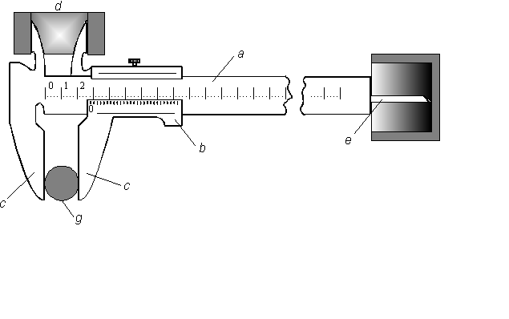 The main parts of a vernier calliper are a basic scale ruler (a) and a short scale ruler (vernier) (b) made to slide along the divisions of basic ruler for indicating parts of divisions (see Figure 1).
Figure 1.
The vernier scale with accuracy 0.1 mm is shown in Figure 2.
Figure 2.
In Figure 2 the upper scale represents 10 mm of the basic ruler, and the lower one represents 9 mm of the vernier. So, one division of vernier scale is 0.1 mm shorter than that of basic ruler. The divisions of vernier are made in such a way: one division of vernier corresponds to $\frac{m−1}{m}=1−\frac{1}{m}$ divisions of the basic ruler, where m is the number of vernier divisions. It is capable of measuring linear dimensions with accuracy $\frac{1}{m}$ of the basic scale.
Let y be the spacing of the basic scale divisions, and x be the spacing of vernier divisions. It is clear that $x=y−\frac{y}{m}$ or $\text{mx}=(m−1)y$. The quantity
$Δx=y−x=\frac{y}{m}$ is called the accuracy of a vernier.
In an arbitrary position of vernier relative to the main scale ruler, one of the vernier divisions coincides with a certain basic scale division. The idea of the vernier method is based on the ability of our eyes to indicate this coincidence of divisions.
Let L be the measurable length. Let the first end of the vernier coincides with the zero division of the basic scale, and the second end be between the divisions k and (k + 1). So, L = (ky + ΔL), where ΔL is yet unknown. Now put the zero division of vernier to the end of measurable length. Because divisions of both scales are different, the nth vernier division coincides with a certain basic scale division, and we can write
$ΔL=\text{ny}−\text{nx}=n\left(y−x\right)=nΔx$. (1)
The total length is $L=\text{ky}+nΔx$ or
$L=\text{ky}+n\frac{y}{m}$. (2)
If measuring surfaces of sliders (c) are in contact, the zero vernier and basic scale divisions coincide. It is easy to see that the distance between the first division of vernier and the neighboring division of basic scale is 0.1 mm, for the second division this value is 0.2 mm, and so on, up to the ninth division where the distance is 0.9 mm. For example, when you shift the vernier slider a little to the right and the vernier division number eight coincides with the closest division of the basic scale, this means that the vernier slider has been shifted at a distance of 0.8 mm.
The measuring procedure is the following: the body to be measured is inserted between the contact surfaces of sliders (you press slightly the vernier sliders to the body to be measured). The integer number of millimeters is read on the basic scale (up to the zero division of the vernier). Decimal pieces are read by the vernier division which coincides with the basic scale division. The method of measuring by a calliper with accuracy 0.05 mm is the same.
Using a calliper, you can measure not only the outside dimensions of a body, but also its inside dimensions, for example, the inside diameter of a boring (Figure 1d) or the depth of a boring (Figure 1e).

Micrometer (Fig. 3)
Figure 3.
A cramp (7) and a sleeve (3) are tightly joined. There are a reading line and sliding scale (0.5 mm divisions) on the sleeve. A micrometry thread with a pitch of 0.5 mm is cut in the inner part of the sleeve. A spindle (2) can move inside the sleeve. A thimble (5) is joined with a spindle (2) by a coarse adjustment screw (is not shown) and can be adjusted in a right position relative to the spindle. There are fifty longitudinal divisions along the round thimble.
When the spindle and an anvil (1) are in contact, zero divisions of the thimble and reading line of the sleeve coincide. In order to simplify the measurement procedure, a coarse adjustment screw with a ratchet (6) is provided. With the help of the ratchet, the pressure upon the body is under control. The thread pitch of the micrometer is 0.5 mm. The upper and lower reading lines (3) are also shifted by 0.5 mm. So, one turn of the thimble results in the spindle displacement at 0.5 mm, and two turns – at 1mm.
In order to measure the linear dimension of a body, you ought to insert it between the spindle and the anvil and by turning the ratchet, to press it slightly. The right position of the body is indicated by a slight ratchet drill. Then you can read the measurement: millimeters are being read on the reading line and the decimal places – on the sliding scale.

Procedure

Use a calliper to measure the length (a), width (b) and height (c) of a parallelepiped and record the data in Table 1. Each dimension must be measured five times.
- Calculate the average values of a, b, and c.
- Calculate the parallelepiped volume $\tilde{V}=\tilde{a}\tilde{b}\tilde{c}$.
Table 1.
No. | a (mm) | b (mm) | c (mm)
1
2
3
4
5
Average | $$\tilde{a}$$ | $$\tilde{b}$$ | $$\tilde{c}$$

- Use a micrometer to measure the height (h) and diameter (d) of a cylinder and record the data in Table 2.
Table 2.
No. | h (mm) | d (mm)
1
2
3
4
5
Average | $$\tilde{h}$$ | $$\tilde{d}$$

- Calculate the average values of h and d.
- Calculate the cylinder volume $\tilde{V}=\frac{π{\tilde{d}}^{2}}{4}\tilde{h}$.

Error Analysis

- Calculate the standard deviation of an average quantity
${\tilde{σ}}_{\tilde{a}}=\sqrt{\frac{{\left(\tilde{a}−a_{1}\right)}^{2}+\text{.}\text{.}\text{.}+{\left(\tilde{a}−a_{5}\right)}^{2}}{5⋅4}}$.
- Calculate the random error $Δ{\tilde{a}}_{r}=2\text{.}\text{78}⋅{\tilde{σ}}_{\tilde{a}}$, where 2.78 is Student’s coefficient for five measurements and 0.95 is the confidence probability.
- Calculate the error of individual measurement
$$Δ{\tilde{a}}_{i\text{.}m}=\frac{1}{2}0\text{.}\text{95}⋅0\text{.}1=0\text{.}\text{0475}\text{ mm}$$
Here 0.95 is the confidence probability and 0.1 is the accuracy of caliper.
- Calculate the total error
$Δ\tilde{a}=\sqrt{Δ{\tilde{a}}_{r}^{2}+Δ{\tilde{a}}_{i\text{.}m}^{2}}$.
- Do analogous calculations to determine the errors Δb and Δc.
6. Calculate relative, ε, and absolute, $Δ\tilde{V}$, errors
$Δ\tilde{V}=\tilde{V}\sqrt{{\left(\frac{Δ\tilde{a}}{\tilde{a}}\right)}^{2}+{\left(\frac{Δ\tilde{b}}{\tilde{b}}\right)}^{2}+{\left(\frac{Δ\tilde{c}}{\tilde{c}}\right)}^{2}}$ and $ε=\frac{Δ\tilde{V}}{\tilde{V}}$.
- Round off $Δ\tilde{V}$ to the nearest tenth and $\tilde{V}$ to the same significant digit. Give the result in the form:
$V=\tilde{V}+Δ\tilde{V}$.
- Calculate the total error
$Δ\tilde{a}=\sqrt{Δ{\tilde{a}}_{r}^{2}+Δ{\tilde{a}}_{i\text{.}m}^{2}}$.
- Do analogous calculations to determine the errors Δb and Δc.
6. Calculate relative, ε, and absolute, $Δ\tilde{V}$, errors
$Δ\tilde{V}=\tilde{V}\sqrt{{\left(\frac{Δ\tilde{a}}{\tilde{a}}\right)}^{2}+{\left(\frac{Δ\tilde{b}}{\tilde{b}}\right)}^{2}+{\left(\frac{Δ\tilde{c}}{\tilde{c}}\right)}^{2}}$ and $ε=\frac{Δ\tilde{V}}{\tilde{V}}$.
- Round off the value of $Δ\tilde{V}$ to the nearest tenth and $\tilde{V}$to the same significant digit. Give the result in the form:
$V=\tilde{V}+Δ\tilde{V}$.

Experiment 2. Measuring the free-fall acceleration

Objective: Measuring the free-fall acceleration.
Devices and instruments: A special setup (a magnet, a timer, a basket, and a long rod) and a number of steel balls.
Theoretical principles
In a dynamical (noninertial) reference frame the second Newton’s law can be written in the form:
$ma=−m\frac{∂U}{∂r}n−{mω}^{2}r−{ma}_{0}$. (1)
Here U is the potential energy, $a_{0}$ is the frame linear acceleration, $ω$ is the frame angular velocity, and $r$ is the radius-vector.
In the present work, we will discuss the free fall of a small sphere in the gravitational field of the Earth. So, $ω$ is the angular speed of the Earth. In the strict sense, the Earth is noninertial frame, and we ought to discuss every term on the right side of Eq. (1) before the derivation of the formula for the free-fall acceleration.
- $−\frac{\text{dU}}{\text{dr}}$ is a force acting between the body and the Earth (we do not take into account some other fields and forces).
$−\frac{dU}{dr}={\text{mg}}_{0}$, (2)
where$g_{0}$ is the “true” free-fall acceleration. Equation (2) can be written in the form
${\text{mg}}_{0}=γ\frac{\text{mM}}{R^{2}}$. (3)
Here M is the Earth’s mass, R is the Earth’s radius, R=7.37·10⁶ m, and γ is the gravitational constant, $g=6\text{.}\text{67}$·10⁻¹¹ (SI). So,
$g_{0}=γ\frac{\text{mM}}{R^{2}}≈9\text{.}\text{81}$ m/s². (4)
2) In Eq. (1), $a_{0}=0$, because there is no linear acceleration when the Earth moves in space.
3) $\overset{˙}{ω}$is negligibly small, and it is quite natural to neglect the force of such a type. Of course, the Earth’s axis nutates and precesses, but their influence is practically zero. Indeed, the Earth’s axis makes one turn (precession) during 26000 years and one 10°-oscillation (nutation) during 18.6 years. The values of ${\overset{˙}{ω}}_{p}$ and ${\overset{˙}{ω}}_{n}$ are
${\overset{˙}{ω}}_{p}=\frac{2π}{\text{26000}⋅\text{365}⋅\text{24}⋅\text{3600}}=0\text{.}\text{64}⋅{\text{10}}^{−9}$ s⁻² (precession),
${\overset{˙}{ω}}_{n}=\frac{2π}{\text{360}⋅\text{18}\text{.}6⋅\text{365}⋅\text{24}⋅\text{3600}}=1\text{.}2⋅{\text{10}}^{−9}$ s⁻² (nutation).
- The Coriolis acceleration $a_{\text{cor}}=[\text{vω}]$. For high speeds its value cannot be so small in comparison with g. But in our experiment $v≤\text{10}$m/s, and
$a_{\text{cor}}≈\frac{\text{10}⋅\text{2π}}{\text{24}⋅\text{3600}}≈9⋅{\text{10}}^{−4}≈{\text{10}}^{−3}$m/s²$»{\text{10}}^{−4}g\text{.}$
The maximum accuracy of our experiment is 0.1% = 10⁻³. So we neglect the Coriolis force.
- In Eq. (1) the centrifugal force is F_{c} = mω² Rsinϕ. In our case ϕ = 56° (the Tomsk latitude), so
$a_{c}={mω}^{2}R\text{sin}ϕ={\left(\frac{\text{2π}}{\text{24}⋅\text{3600}}\right)}^{2}⋅6\text{.}4⋅{\text{10}}^{6}{\text{sin56}}^{∘}=2\text{.}8⋅{\text{10}}^{−2}≈3⋅{\text{10}}^{−3}g$,
and we cannot consider this force to be negligible. Taking into account the preceding, we can write (see Fig. 1)
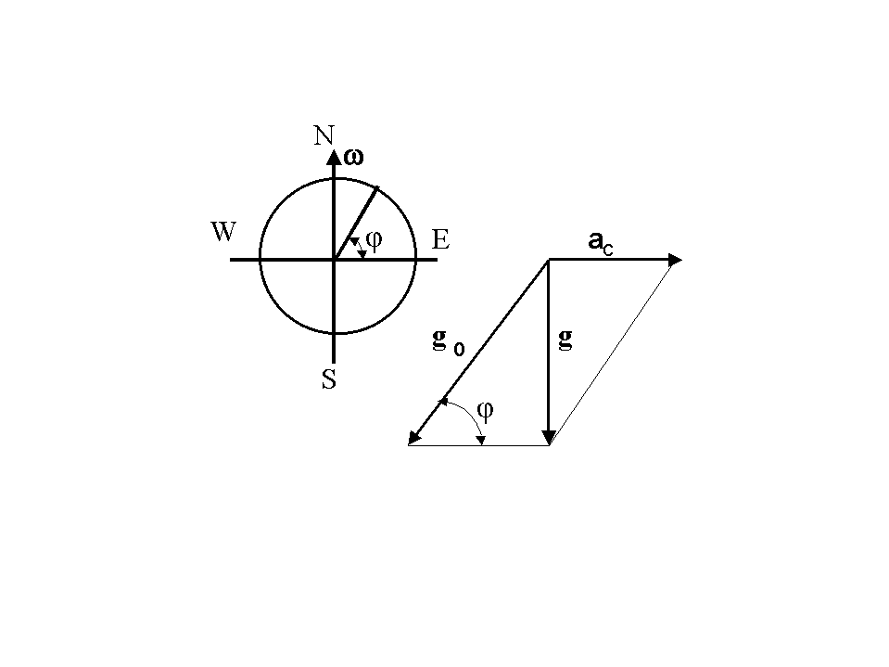
$g=g_{0}+α_{c}$. (5)
The quantity P = mg is called the body’s weight.
The discrepancy $(g_{0}−g)$ is zero at the Earth’s poles and is 0.3% of g on the equator. The Earth is a slightly oblate, and the free-fall acceleration g varies with latitude ϕ. At the equator, g is 0.2% less then at the poles. The value of g changes from g = 9.780 m/s² at the equator to g = 9.832 m/s² at the poles.
Figure 1. The standard value of g is taken to be g =
9.780 m/s².
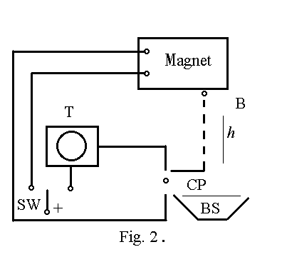

Figure 2.

Experimental arrangement

In the normal position, the double-contact switch (SW) is turned to the left and the electric current runs through the magnet, the iron ball (B) being hold by the magnet. If the switch is turned to the right, the current through the magnet is broken, and the ball begins to fall. At that moment, the electric timer (T) starts. The ball strikes the contact plate (CP), and the timer stops. The ball falls into the basket (BS). Knowing the time of fall and the distance h, it is easy to calculate the value of the free-fall acceleration g:
$h=\frac{{\text{gt}}^{2}}{2},$ $g=\frac{h}{t^{2}}\text{.}$ (6)

Work order
- With the help of a long ruler, measure the distance h (h is about 2 meters).
- Push the tumbler (SW) to the left position, and with the help of the long rod pull the ball to the magnet.
- Push the tumbler (SW) to the right position and record the time of free fall.
- Repeat the procedure no less than five times, and write down the data in Table 1.
- Repeat the experiment with another ball.
Table 1.

No. | $$t$$ | $$\bar{t}$$ | $$l$$ | $$g$$ | $$Dg$$
1
.
.
5
Note: Because of the magnetic inertia, the ball does not start to fall immediately after the electric circuit has been broken, and this time delay must be subtracted from time $\bar{t}$. (The time delay is given).
- Calculate the experimental error.
- Taking into account that $a_{c}\text{<<}g$, it is rather easily, using Figure. 1, to obtain
$g_{0}=g\left(1+\frac{a_{c}}{g}\text{sin}ϕ\right)$ (7)
or $g_{0}=g\left(1+\frac{2\text{.}8⋅{\text{10}}^{−2}}{9\text{.}8}{\text{sin56}}^{o}\right)=g(1+2\text{.}4⋅{\text{10}}^{−3})=1\text{.}\text{0024}g$. (8)
Calculate the Earth’s mass using the formula
$\frac{γM}{R^{2}}=g_{0}, M=\frac{g_{0}R^{2}}{γ}, γ=6\text{.}\text{67}⋅{\text{10}}^{−\text{11}}, R=6\text{.}3⋅{\text{10}}^{6}$. (9)
Compare this value with the tabulated one.

Experiment 3. Determining the coefficient of sliding friction

If we put a physical body on a surface and begin to pull it, we must overcome some force even if this surface is horizontal. The forces of that kind are called the friction forces. They are present everywhere and by the way, are quite necessary for walking and driving.
Static friction. If with the help of a dynamometer we begin to pull a bar along the plane, we can see that the bar starts moving only when the acting force is greater than some threshold value. While the driving force is smaller than the threshold value, the bar is at rest, and the friction force F_{f} and the driving force F are exactly the same. This friction force is called the static friction force. Its value is $0≤F_{f}≤F '_{f,\text{max}}$ and depends on the normal force F_{N} (i.e., the component of the force perpendicular to the plane); in such a way, $F'_{f,\text{max}}=k'F_{N}$, where k' is the dimensionless coefficient of static friction which depends on the characteristics of both contact surfaces.
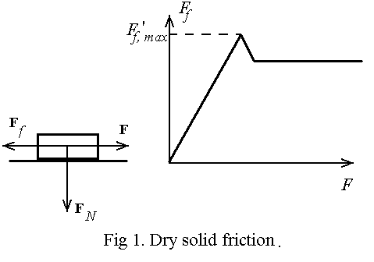
Figure 1. Dry solid frction.
Sliding friction. When the driving force is greater than $F '_{f\text{,max}}$, the body begins to move. The measurement of the friction force F_{f} in motion is especially simple when the body moves at a constant speed. In this situation we have
$$0=F+F_{f}$$
(The total force is equal to zero when the body moves at a constant speed).
The absolute value of the friction force $F_{f}$ is the same as that of the driving force $F$, but of course their directions are opposite. By analogy with the static friction we can use the coefficient of sliding friction k in accordance with the following relation:
$\left|F_{f}\right|=k\left|F_{N}\right|$.
The relation between the forces of static and sliding friction is: $F_{f, \text{sf}}≥F_{f, \text{sl}}$, and we have $k'≥k$.
In the first approximation, the force of sliding friction between dry surfaces does not depend on the speed. That is quite different from the other kinds of friction, for example, in a viscous medium or in the air, where the friction force depends strongly on the velocity.
Friction on an inclined plane
A body on an inclined plane starts moving only when the downward force $\text{mg}\text{sin}α$ is greater than the maximum force of static friction $\text{mg}\text{sin}α≥k'\text{mg}\text{cos}α$, in other words $\text{tanα}≥k'$. With the help of this relation, $k'$ can be evaluated by measuring the angle α when the body begins to move. The coefficients of static and sliding friction for several pairs of materials are given in the table below.
Figure 2.

Materials | $$k'$$ | K
Iron-iron | 0.15 | 0.09–0.03
Iron-wood | 0.6 | 0.5–0.2
Iron-ice | 0.027 | 0.014 (sledge, skates)
Rubber-asphalt | 0.9 | 0.85  0.45 (damp)
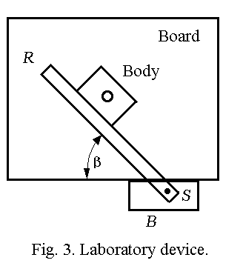
Figure 3. Laboratory device.
Description of the laboratory
device
The laboratory device consists of a drawing board and a T-square. The T -square has two elements: a ruler R and a driving block B. The driving block is connected with the ruler by a screw S and can be set at different angles β (Fig.3). When the ruler moves to the right at a constant speed, the body moves upward along the ruler. There is a small (d ≈ 1 cm) orifice in the center of the body. The ruler and the body can be made from different materials. In our laboratory the ruler is made from duralimin; on one side of the body surface there is a plate made from brass, and on the other side there is a plate made of rubber.
Theoretical principles
A body moves on a horizontal plane. Because of this, we must take into account only horizontal forces which act in this plane: the normal force $F_{N}$ perpendicular to the friction plane, the sliding friction force $F_{f}$ parallel to the friction plane, and the force $F_{B}$ of friction between the board and the body.
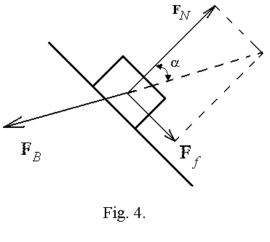

Figure 4.
When the body moves at a constant speed, we have: $F_{N}+F_{f}+F_{B}=0$
The direction of the force$F_{B}$ depends on the forces $F_{N}$and $F_{f}$. The direction of motion and the vector $F_{B}$ are opposite and just because of this the body moves in the direction which is given by the geometrical sum of vectors $F_{N}$and $F_{f}$. This motion is schematically shown in Figure 5.
In accordance with Figures 4 and 5, $k=\text{tanα}=l_{1}l_{2}$.
Here A₀ and A₁ are the initial and final positions of the body. Through the orifice in the body we can mark these points with the pencil on a sheet of paper. A₀A₂ = l₂ is the distance measured along the normal to the ruler between the initial and final positions of the body.
Figure 5. A₁A₂ = l₁, A₀A₂ = l₂.
Work order
- Put a sheet of paper (about 20 × 20 cm²) on the drawing board and fix it by putty or drawing-pins. Lay the ruler on the paper at angle β (see Figure 3) equal to 30° and move it to the left.
- Lay the body on the ruler as shown in Fig. 3 and mark the initial position of the body by a pencil (Figure 5, point A₀).
- Very cautiously and without jabs move the driving block to the right and mark the final position of the body (Figure 5, point A₁).
- Do all necessary geometrical drawings and measure the distances l₁ and l₂. Write down these values in the table. Repeat the experiment five times.
- In order to be sure that the value of the coefficient of sliding friction does not depend on the friction force acting between the body and the board, lay a 200-g weight on the body and repeat items 1-4.
- In order to be sure that the coefficient of sliding friction does not depend on the normal force F_{N}, lay the ruler at the angle β equal to 60° and repeat items 1-4.
- Repeat items 1-6 for an other pair of materials.

Table 1.
Pair | No. | Weight, g | β,° | l₁ | l₂ | $$k={l_{1}}/{l_{2}}=\text{tanα}$$ | $$\bar{k}±Δk$$
Duralimin-brass | 1  2  .  . | 0 | 30
Duralimin-brass | 1  2  .  . | 200 | 60
Duralimin-brass | 1  2  .  . | 0 | 60

Table 2.
Pair | No. | Weight, g | β,° | l₁ | l₂ | $$k={l_{1}}/{l_{2}}=\text{tanα}$$ | $$\bar{k}±Δk$$
Duralimin-  rubber | 1  2  .  . | 0 | 30
Duralimin- rubber | 1  2  .  . | 200 | 60
Duralimin- rubber | 1  2  .  . | 0 | 60

Attention! You can simplify the experimental procedure if instead of the values l₁ and l₂ you measure the angle α with a protractor and then calculate tanα.
- Calculate the absolute errors for every run (items 1-5 in Tables 1 and 2)
$Δk=t_{\text{α,n}}\sqrt{\frac{\sum_{1}^{n}{{\left(\bar{k}−k_{i}\right)}^{2}}}{n(n−1)}}$.
Here $t_{\text{α,}n}$ is Student’s coefficient, n is the number of measurements, and α is the confident probability (for α = 0.95 and n = 5, $t_{\text{α,n}}$=2.78).
- Using the experimental data, draw some conclusions concerning this laboratory work.

Experiment 4. Studying the distribution function of random variables

Objective: Plot an experimental histogram of the distribution of random variables and compare it with the Gauss theoretical distribution; give no less than ten evaluations of average values (with the help of student’s coefficients) for n = 3, 5, and 10 successive measurements.
Devices and Instruments
An electric timer.
Basic theoretical principles
Very many natural variables x are distributed in accordance with the gauss law which can be written in the form
$f(x)=\frac{1}{\sqrt{\text{2πσ}}}e^{−\frac{(\bar{x}−x)^{2}}{2σ^{2}}}$. (1)
Here $\bar{x}$is the arithmetic average, and σ is the standard deviation.
The value of σ is the main characteristic of measurements and depends on the method of measurements, accuracy, and properties of the variable. In the special course of the probability theory it is shown that
$σ=\underset{n→∞}{\text{lim}}\bar{σ}$, (2)
where n is the number of measurements, and $\bar{σ}$ is the standard deviation of the estimate of the mean
$\bar{σ}=\sqrt{\frac{\sum_{1}^{n}{(\bar{x}−x_{i})^{2}}}{n\text{}(n−1)}}$ , (3)
$\bar{x}=\frac{\sum_{1}^{n}{x_{i}}}{n}$. (4)
In practice for n ≥ 100 it is quite possible to take $σ≈\bar{σ}$.
It has been shown by English mathematician W. Gosset (pseudonym Student) that for n measurements the confidence interval can be expressed as follows:
$Δx=t_{\text{α,}n}\bar{σ}$. (5)
Here $t_{α,n}$ is the so-called student’s coefficient which depends on the number of measurements and on the confidence probability (in our laboratory, α = 0.95). For example, t_{α,n} = 2.78 ( n = 5), t_{α,n} = 4.3 ( n = 3), and t_{α,n} = 2.2 ( n = 10).
Obviously, there is a tendency: the greater $n$, the smaller$Dx$.

Work order
- Switch on the electric timer, and when the arm makes one turn, switch it off. Sometimes it will be one second, sometimes some other value. In order to make calculations easier, instead, for example, 1.02 write down 102 in the table, and so on. Do no less than $n=\text{150}$ measurements. In such a way, you will have n random variables x.
- Do necessary calculations
No. | x | $(x−\bar{x})^{2}$
1  2  …  150 | x₁  x₂  …  x₁₅₀ | $(x_{1}−\bar{x})^{2}$  $(x_{2}−\bar{x})^{2}$  …  $(x_{\text{150}}−\bar{x})^{2}$
 | $\bar{x}$ | $\bar{σ}$

- It is very convenient to use the procedure which is clear from the figure below.

Here, each point corresponds to one measurement. The total number of points is of course n.
- Divide the total range x into equal sections (intervals) including 1, 2, or 3 runs with the same x in such a way as to have $6−\text{10}$ intervals. Count the number of points in each interval and write them down in the table below. Here Δx is the length of the interval, and ${\bar{x}}_{i}$ is its center.

No. | Interval | Number of  points n_{i} | $f_{i}=\frac{n_{i}}{nDx}$ | $f({\bar{x}}_{i})$
1  2  3  …  …  …  10 |  | $n_{1}$  $n_{2}$  $n_{3}$  …  …  …  $n_{\text{10}}$ | $f_{1}$  $f_{2}$  $f_{3}$  …  …  …  $f_{\text{10}}$ | $f({\bar{x}}_{1})$  $f({\bar{x}}_{2})$  $f({\bar{x}}_{3})$  …  …  …  $f({\bar{x}}_{\text{10}})$

This table is just an example. You may have your own subdivisions. It is useful to take the end points of each interval between the integer values x and write them down in the column Interval. The values f_{i} represent the frequency of finding the random variable x in the ith interval. As $n→¥$, $f_{i}→f(x_{i})$, where $f(x_{i})$ is the Gauss distribution.
- For calculated values plot the histogram and compare it with the Gauss distribution. An example of such a histogram is shown in the figure below. The solid curve shows the Gauss distribution.

- Take at random 3, 5, and 10 successive runs, every number several times, and with the help of Eqs. (3), (4), and (5) evaluate $\bar{x}$ and $Δx$ for every run.
Present this result in the form given below

The number to the right of every rectangle indicates the number of measurements in the run, the length of the rectangle is $2Dx$, and the middle point is $\bar{x}$ for the given run. Plot no less than ten calculations of this kind.
- Give some conclusions concerning the results of experiment.

Experiment 5. Elastic and inelastic collisions of balls

Objective: Studying the laws governing elastic and inelastic collisions of balls and determining the elasticity coefficient for different pair of balls.

Devices and Instruments: Special arrangement for experiments with balls and different balls.

Theoretical principles
In mechanics, collisions are described as a short interaction of two or several bodies when these bodies are brought in contact. The straight line through the contact point perpendicular to the contact surface is called the line of collisions. The collision is called central when the centers of mass of colliding bodies are at the line of collision. There are two kinds of impacts: elastic and inelastic. When the collision is elastic, the total kinetic energy does not change. The collision is called perfectly inelastic, when after collision two bodies move as a whole. The collision can be characterized by the ratio K = E₂/E₁, where E₂ and E₁ are kinetic energies after and before collision, respectively. Of course, E₁ and E₂ are total kinetic energies of the colliding bodies. Obviously, 0 K 1.
If a ball with mass m₁ and speed v₁ strikes a ball at rest ( v₂ = 0 ) with mass m₂, the law of conversation of momentum holds:
m₁ v₁= m₁ u₁ + m₂ u₂ , (1)
where u₁ and u₂ are the velocities of the balls after impact.
The balls are hung like pendulums (Fig.1) and collide when they are in the lowest position. The velocities can be determined if the angles of deviation are known. Obviously,
$v=\sqrt{2gh}$, (2)
$h=l\left(1−\text{cos}α\right)$ or $h=2l{\text{sin}}^{2}\frac{α}{2}$. (3)
So, $v_{1}=2 \sqrt{gl}\text{sin}\frac{α}{2}$, $u_{1}=2 \sqrt{gl}\text{sin}\frac{α^{1}}{2}$, $u_{2}=2 \sqrt{gl}\text{sin}\frac{β}{2}$. (4)

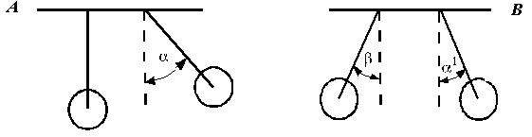Figure 1. Before impact (A) and after it (B).

Using Eq. (4), we can rewrite Eq. (2) in the form
$m_{1}\text{sin}\frac{α}{2}=−m_{1}\text{sin}\frac{α}{2}+m_{2}\text{sin}\frac{β}{2}$. (5)
This equation can be checked experimentally.
The value of K can be expressed as follows:
$K=\frac{m_{1}{\text{sin}}^{2}\frac{α^{1}}{2}+m_{2}{\text{sin}}^{2}\frac{β}{2}}{m_{1}{\text{sin}}^{2}\frac{α}{2}}$. (6)

Work order

- Measure masses of the balls with a scales.
- Hang the balls in such a way that the collision is central.
- Push the right ball to an electromagnet and measure the angle$α$.
- With the help of a cutout switch, break the electric current and measure the angles α¹ and $β$. Do it at least five times.
- Check Eq. (5) and calculate the value of K.
- Repeat the experiment for the next pair.
- The measurement error can be evaluated from the formula
$ΔK=2\text{.}\text{78} \sqrt{\frac{(K_{1}−K)^{2}+\text{.}\text{.}\text{.}+(K_{5}−K)^{2}}{\text{54}}}$, $n=5$. (7)

Ball (right) material Ball (left) material
No. | α | α¹ | β | K
1  2  3  4  5 |  |  |  |  | m₁ = (right)  m₂ = (left)  ΔK =  left side of Eq. (5)  right side of Eq. (5)
 | α | α¹ | β | K
Note: To check Eq. (5), use the average values of angles.

Experiment 6. Studying dynamics laws with Atwood’s machine

Objective: Checking Newton’s second law with the help of Athwood’s machine.

Devices and Instruments: Athwood’s machine, main weights, additional weights, and an electrical stop-watch.

Figure 1.

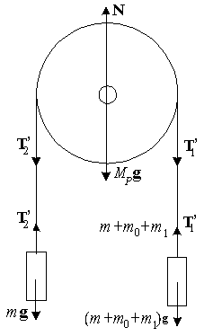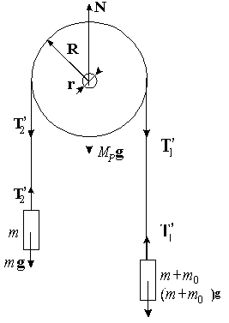
Figure 2. Figure 3.

Experimental device and basic theoretical principles

Atwood’s machine (Figure 1) consists of a vertical bar equipped with a balance and a light pulley that can rotate in the vertical plane. Two identical main weights A and B (the mass of each weight is m) are connected by a thin thread. The weight A can be fixed in the upper position by an electromagnet EM. In the lower part of the machine there is a special platform C with a control plate. The control plate is electrically connected to a stop-watch. When the weight A strikes the platform, the stop-watch is switched off.
The work consists of two parts.

Part 1

The total force acting on the pulley (in the vertical direction) is zero. The pulley does not move in the vertical direction. So (see Figure 2) we can write
$N=M_{p}⋅g+T_{1}+T_{2}$ (1)
Here N is the normal reaction. The force of friction is $F_{\text{fr}}=kN$, so we can write the expression for the frictional torque in the form:
$M_{f}=k(M_{p}g+T_{1}+T_{2})r$. (2)
The friction coefficient k can be found from rather simple considerations.

Let us assume that there is a mass m₀ additional to the right mass m, and its value is such that the total system moves at a constant speed (if A is pushed slightly downwards). This means that $(T_{1}−T_{2})R=m_{0}g R$, $T_{1}=(m+m_{0})g$, and $T_{2}=m g$. The first equation shows that the friction torque and the torque produced by external forces are equal. The second and the third equations hold, because the speed is constant. Using these equations, we can rewrite Eq. (2) in the form:
$M_{f}=m_{0}R\frac{M_{p}g+T_{1}+T_{2}}{M_{p}+2m+m_{0}}$, (3)
$k=\frac{m_{0}R}{(M_{p}+2m+m_{0})r}$. (4)

If there is a mass m₁ additional to the right weight A, the system moves with an acceleration a (see Figure 3). Thus, tension in the thread can be given as follows:
$T_{2}=m(g+a)$, $T_{1}=(m+m_{1}+m_{0})(g−a)$. (5)
The resultant torque (taking into consideration that $a\text{<<}g$) can be expressed as follows:
$M=\left[(m_{1}+m_{0})g−ma\right]R$, (6)
and the frictional torque is
$M_{f}=m_{0}gR$. (7)
In accordance with the basic law of motion in rotation, we have
$M−M_{f}=Jε$. (8)
Here $J=\frac{M_{p}⋅R^{2}}{2}$ is the rotary inertia of the pulley, and $ε=\frac{a}{R}$ is the angular acceleration of the pulley.
Using Eqs. (6) and (7), we have
$a=\frac{m_{1}g}{2m+\frac{M_{p}}{2}}$. (9)
Form formula (9) a very interesting fact can be seen: there are neither m₀ nor k. Formula (9) gives the acceleration of a system without friction (the mass m₀ compensates for the friction force), and only the mass m₁ acts.
Note: In this experimental arrangement the friction torque has already been compensated, and the weights are marked R for right and L for left ones.
Task 1. Checking formula (9).
It is well known that when $a=\text{const}$, it can be found from the formula
$a=\frac{2S}{t^{2}}$. (10)
So, you have to compare the values given by Eqs. (9) and (10).

Work order
- Place the weights A and B in the initial position, the tumbler switch in EM position. The electric current will flow through the electromagnet coil and the weight A will be fixed in the upper position.
- Put the additional weight m₁ on the main weight A. Lift the platform C up. The electrical circuit of the timer will be ready for operation. Measure the distance s ($S»\text{40}$cm). The value of s is being given by the professor.
- Switch the tumbler in ES position. At this moment, the electromagnet circuit is broken, and the timer begins to count. After the weight A strikes the platform, the timer is switched off.
- For every additional weight, the experiment must be repeated 3 − 5 times. Then it is necessary to find the average time of weight motion and using formula (10), find the acceleration.
- Compare the values of a given by formulas (9) and (10).
- Note: All the data are to be written in Table 1.

Table 1
No. | m₁  [g] | 2m  [g] | M_{p}  [g] | S  [cm] | t  [s] | $\bar{t}$  [s] | $$a=\frac{2S}{t^{2}}$$ | $\overline{a}$
1
2
3
4
5

Part 2

From Newton’s second law we have:
$\frac{a_{1}}{a_{2}}=\frac{F_{1}}{F_{2}}$ (if the mass does not change). (11)
Task 2 is to check Eq. (11).
If we put mass m₂ on A and mass m₁ ($m_{2}>m_{1}$) on B, then $F_{1}=(m_{2}−m_{1})g$.
If we put both masses on A, then $F_{2}=(m_{1}+m_{2})g$.
So, $\frac{F_{1}}{F_{2}}=\frac{m_{2}−m_{1}}{m_{1}+m_{2}}$. (12)
But according to Eq. (11), we obtain
$\frac{F_{1}}{F_{2}}=\frac{a_{1}}{a_{2}}=\frac{t_{2^{2}}}{t_{1^{2}}}$. (13)
So, in this experiment it is necessary to compare Eqs. (12) and (13).
Note: All the data must be put in Table 2.

Work order: The same as in Part 1.

Table 2
No. | m₁  [g] | 2m  [g] | $\frac{F_{1}}{F_{2}}$ | S  [m] | t₁  [s] | t₂  [s] | $$\frac{a_{1}}{a_{2}}$$
1
2
3
4
5

Experiment 7. Determining the free path and the effective diameter of a molecule

Objective: Determining the free path and the effective diameter of air molecules.

Devices and instruments: A special arrangement with a burette and a capillary pipe (see fig. 2), a glass, a timer, a capillary slide, a microscope, a ruler, and a graduated glass beaker.

Theoretical principles
In accordance with the molecular kinetic theory, the chaotic motion of molecules is the cause of the so-called transport phenomena: thermal conduction, diffusion, and viscous friction. In spite of the very high values of molecular velocities (≈1 km/s), the transport phenomena are rather slow, because there are very many collisions per second and molecular paths are not straight but broken.
Forces acting between molecules are of considerable values only when the distance between molecules is small (one-two molecular diameter). Just because of this we can consider the paths of molecules between collisions to be straight and the speed to be constant. Only when a molecule strikes another molecules, its path is broken.
In the theory, the concept of the effective molecular diameter $D_{\text{eff}}$ is very important. It is the distance between the centers of molecules when the van der Waals force is zero (Fig. 1). The distance between two collisions is called the free path λ. The mean value of λ can be expressed in the form:
Figure 1.
$\bar{λ}=\frac{1}{\sqrt{2}π{\text{nD}}_{{\text{eff}}^{2}}}$. (1)
Here, n is the number of molecules in the unit volume.
The values of $\bar{λ}$ and $D_{\text{eff}}$ can be measured. In this laboratory work, $\bar{λ}$ and $D_{\text{eff}}$ are being determined with the help of a viscous transport process study. It is well known that the intrinsic viscous coefficient can be expressed in the form:
$η=\frac{1}{3}ρ\bar{λ}⋅\bar{v}$ (2)
Here η is the intrinsic friction coefficient, ρ is the gas density (in our case, the air density), $\bar{λ}$ is the molecular mean free path, and $\bar{v}$ is the average speed. So,
$\bar{λ}=\frac{\text{3η}}{ρ\bar{v}}$ (3)
The values on the right side of this equation can be measured experimentally.
- Determining η
In accordance with the molecular-kinetic theory, the velocity of the gas flow through a capillary pipe (r is its radius and l is its length) can be expressed as follows:
$u=\frac{r^{2}}{Vη}⋅\frac{Δp}{l}$, (4)
where Δp is the pressure difference along the pipe. So, the volume of a gas passing through the capillary pipe during time t, can be written as
$V=\frac{πr^{4}}{8ηl}Δp⋅t$, (5)
and we have $η=\frac{πr^{4}⋅Δp⋅t}{8Vl}$. (6)
- Determining ρ .
From the Mendeleev-Klapeyron equation we obtain
$ρ=\frac{μ⋅p}{\text{RT}}$. (7)
3. Determining $\bar{v}$.
It is well known that $\bar{v}=\sqrt{\frac{8\text{RT}}{\text{πμ}}}$. (8)
So, $\bar{λ}=\frac{3πr^{4}Δp⋅t\sqrt{π\text{RT}}}{\text{16}Vlp\sqrt{2μ}}$. (9)
Here r is the capillary radius, Δp is the pressure difference along the capillary pipe, t is time, T is the temperature, V is the gas volume, p is the gas pressure, l is the length of the capillary pipe, μ is the molar mass, and R is the gas constant per mole.
It is well known that
$\bar{λ}=\frac{1}{\sqrt{2}π{\text{nD}}_{\text{eff}}}$. (10)
Using $p=\text{nkT}$ (k is the Boltzmann constant), we obtain
$D_{\text{eff}}=\sqrt{\frac{\text{kT}}{\sqrt{2}π\bar{λ}p}}$. (11)

Equipment

The experimental arrangement is shown in Figure 2. The burette 1 is filled with water. The upper end of the burette is closed by the rubber plug 2; inside the plug there is a capillary pipe. If the faucet 4 is open, the water flaws down at first by a jet, and them by drops. The air penetrates in the burette through the capillary pipe and the pressure difference is provided
$Dp=ρ⋅\text{gh}$, $h=\frac{h_{1}+h_{2}}{2}$. (12)
Here, $h_{1}$ and $h_{2}$ are the water levels in the initial and final stages of the experiment. It is very important to understand why Δp can be substituted by $ρg\text{}\left(\frac{h_{1}+h_{2}}{2}\right)$. Indeed, in formula (9) there is a combination $\frac{Dp⋅t}{V}$; actually, it must be $\frac{gρh \text{dt}}{\text{dV}}$, but $v_{0}=\frac{\text{dV}}{\text{dt}}$ is the speed of gas flow through the capillary, and $\frac{\text{dV}}{\text{dt}}$~h. So $h/{\frac{\text{dV}}{\text{dt}}}$ is constant, and we can calculate its value in the center of the burette. So $h→\frac{h_{1}+h_{2}}{2}$, and just because $v_{0}\text{\sim }h$, its value in the center can be expressed as V/t. So we have equation (9).

Work order

- Take the plug out and pour water inside the burette. Put the plug back. Do this procedure very cautiously in order not to break the glass.
- Open the faucet (4) and when the water begins to drop, switch on the timer, and note the value h₁.
- When the water is at the level h₂ $(h_{1}−h_{2}»\text{10}$cm), switch off the timer.
- Using the graduated burette, calculate V.
Figure 2. 5. Measure l, T, and p.
- Note: $R=8\text{.}3⋅{\text{10}}^{3}$, $μ=\text{29}$, an $k=1\text{.}\text{38}⋅{\text{10}}^{−\text{23}}$ (SI). All the measured values are to be written down in the table.
6. Repeat the experiment 3−4 times (h₁ and h₂ are the same).
- Measure the capillary radius with a microscope. Make at least 5 measurements in different directions of the capillary orifice and calculate the average value of r.
- Calculate $\bar{λ}$ and $D_{\text{eff}}$.
- Calculate Δ$λ$ and ΔD from the formulas
$\frac{Δ\bar{λ}}{λ}=\sqrt{{\left(4 \frac{ΔR}{R}\right)}^{2}+{\left(\frac{Δα}{α}\right)}^{2}}$, $\frac{ΔD}{D}=\frac{1}{2} \frac{Δλ}{λ}$.

Here: $α=\frac{Δp⋅t}{V}$, $Δα=3\text{.}7\sqrt{\frac{(\bar{α}−α_{1})^{2}+\text{.}\text{.}\text{.}+(\bar{α}−α_{3})^{2}}{6}}$.

