Lab 10. Neural Networks
Function patternnet

Syntax

patternnet(hiddenSizes,trainFcn,performFcn)

Description
le
Pattern recognition networks are feedforward networks that can be trained to classify inputs according to target classes. The target data for pattern recognition networks should consist of vectors of all zero values except for a 1 in element i, where i is the class they are to represent.
patternnet(hiddenSizes,trainFcn,performFcn) takes these arguments,
hiddenSizes
Row vector of one or more hidden layer sizes (default = 10)
trainFcn
Training function (default = 'trainscg')
performFcnPerformance function (default = 'crossentropy')

- Please insert the next text of program in Matlab and read description of new functions for you (use Help). Please study these functions by varying the function arguments and running this code.
%% set network and train
[x,t] = iris_dataset;
net = patternnet(10);
net = train(net,x,t);
view(net)
y = net(x);
perf = perform(net,t,y);
classes = vec2ind(y);
%% Check working network
x1=[5.1; 3.5; 0.4; 0.2];% setosa class 1
y1 = net(x1);
classes1 = vec2ind(y1)
x2=[5.7; 2.8; 4.5; 1.3];% versicolor class 2
y2 = net(x2);
classes2 = vec2ind(y2)

The result should be
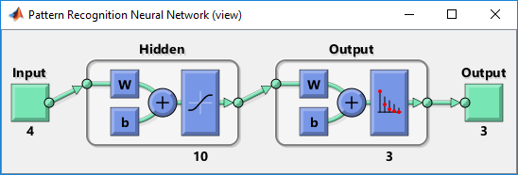
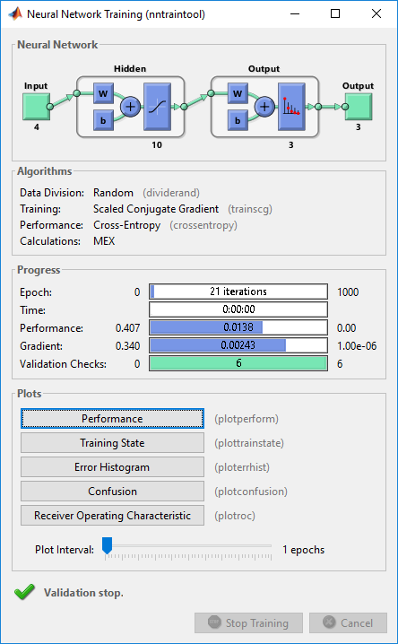
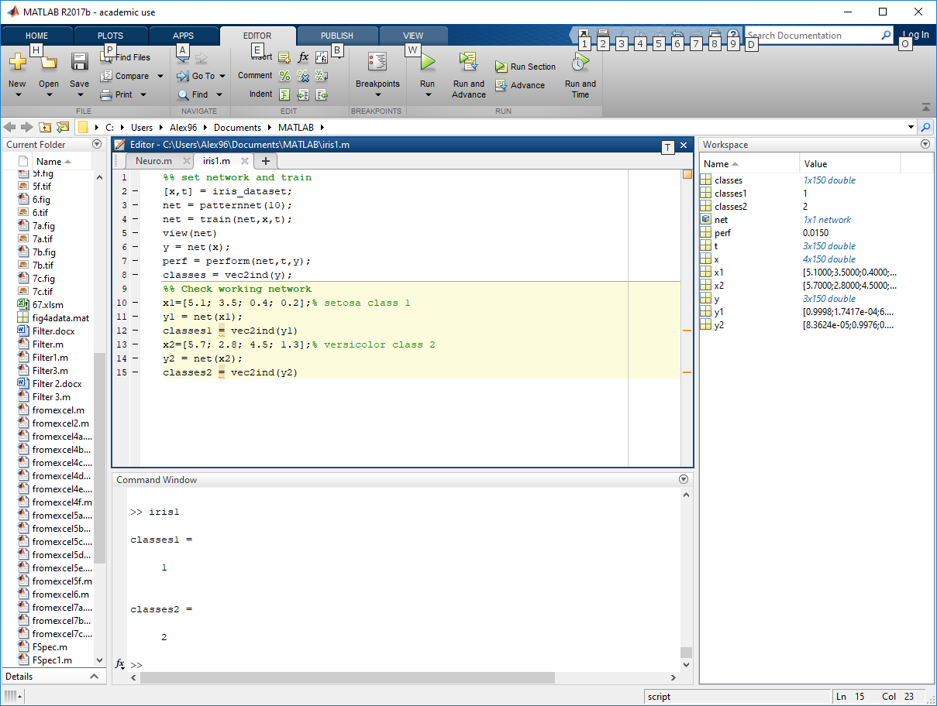
Thus, the neural network after training correctly classified the object according to the parameters we specified.
The Task
For the experiment, we will reduce (using the successive removal of elements) the training sample and again train the neural network with it. Let's see how much the probability of error in classification will increase.
The next program trains the neural network with reduced-size data (instead of a sample of 150 objects, only 30 are used). Also, on the basis of 30 predictions, a conclusion is made about the percentage of correct answers.
%% remove part of the training set
[x_orig, t_orig] = iris_dataset;
[x,t] = iris_dataset;
x(:, 1:40) = [];
x(:, 11:50) = [];
x(:, 21:60) = [];

t(:, 1:40) = [];
t(:, 11:50) = [];
t(:, 21:60) = [];

%% train
net = patternnet(10);
net = train(net,x,t);
view(net)
y = net(x);
perf = perform(net,t,y);

%% Check working network
res = 0; %The number of correctly defined classes
for i=1:30
rand_set_num = rand * 150; %Choosing a random iris
% надо исключить номера которые мы НЕ вырезали ведь на них шло обучение

rand_set_num = int32(rand_set_num);
res = res + check_prediction(net, rand_set_num, x_orig, t_orig);
end

pred_percent = res / 30 * 100 %The percentage of correctly defined classes

%Function to predict class by network and match with true class
function result = check_prediction(net, set_num, x, t)
x_t = x(:, set_num);
y_true = vec2ind(t(:, set_num));

y_get = vec2ind(net(x_t));

if (y_get == y_true)
result = 1;
else
result = 0;
end
end

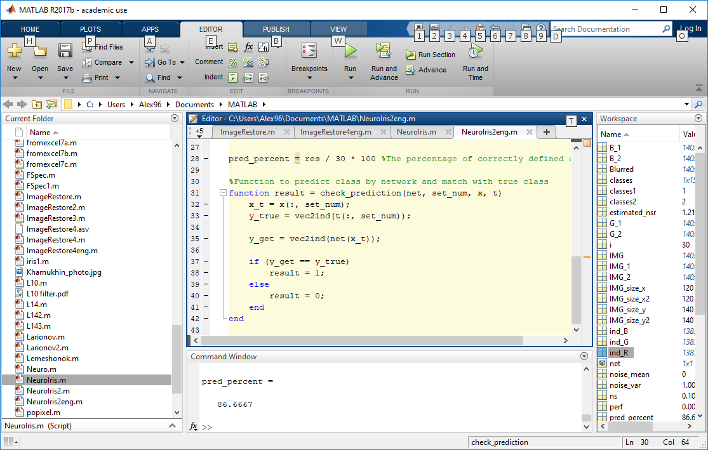

Lesson 16 (on week 17). Neural Networks-2
You must calculate and construct a diagram of the dependence of the number of errors on the size of the training sample.
For example
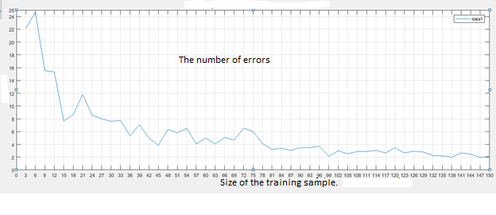
PS
Read more on page https://nl.mathworks.com/help/deeplearning/examples/iris-clustering.html
Серия из 15 испытаний на однм и том же наборе данных (урезанном)

%% remove part of the training set
[x_orig, t_orig] = iris_dataset;
[x,t] = iris_dataset;
x(:, 1:40) = [];
x(:, 11:50) = [];
x(:, 21:60) = [];

t(:, 1:40) = [];
t(:, 11:50) = [];
t(:, 21:60) = [];

%% train
net = patternnet(10);
net = train(net,x,t);
view(net)
y = net(x);
perf = perform(net,t,y);

%% Check working network

for j=1:15 %это кол-во точек на графике эффективности

res = 0; %The number of correctly defined classes
for i=1:30 %это кол-во проверок
rand_set_num = rand * 149+1; %Choosing a random iris от 1 до 150
% надо исключить номера которые мы НЕ вырезали ведь на них шло обучение

rand_set_num = int32(rand_set_num);
res = res + check_prediction(net, rand_set_num, x_orig, t_orig);
end
pred_percent = res / 30 * 100 %The percentage of correctly defined classes
% График
x_new = j;
y_new = pred_percent;
hold on;
plot(x_new, y_new, '-ro', 'MarkerSize', 4, 'LineWidth', 2); % Добавить "o" красного цвета

end

%Function to predict class by network and match with true class
function result = check_prediction(net, set_num, x, t)
x_t = x(:, set_num);
y_true = vec2ind(t(:, set_num));

y_get = vec2ind(net(x_t));

if (y_get == y_true)
result = 1;
else
result = 0;
end
end

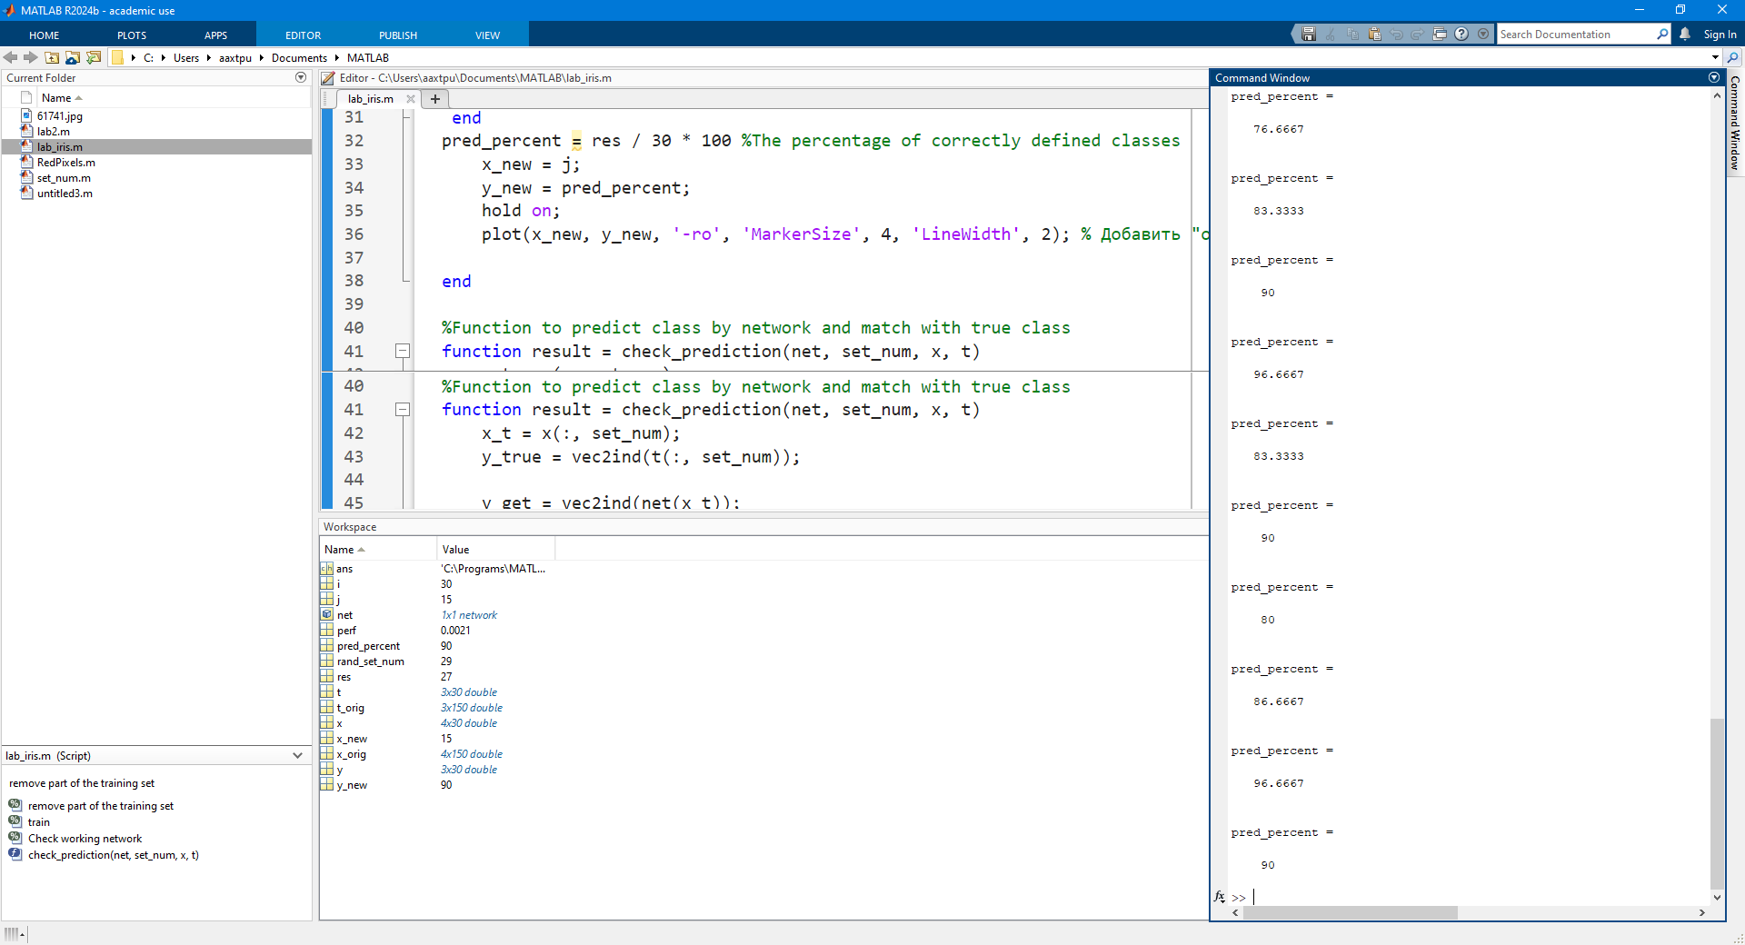
Даже на одном и том же наборе данных НС дает разную эффективность
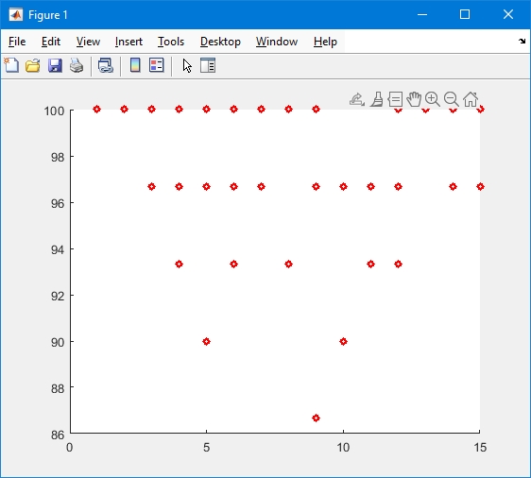
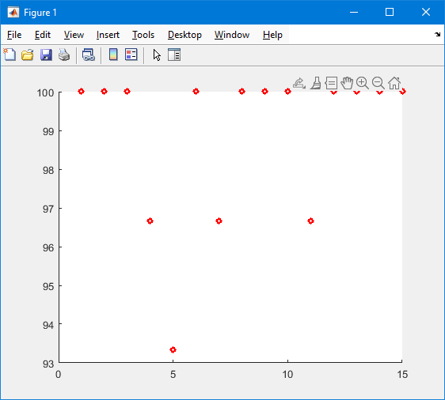
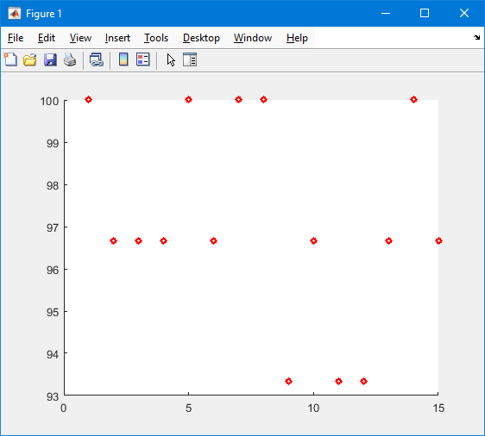
последний – сильн6о урезанный
x(:, 1:40) = [];
x(:, 51:90) = [];
%x(:, 101:140) = [];

t(:, 1:40) = [];
t(:, 51:90) = [];
%t(:, 101:140) = [];

