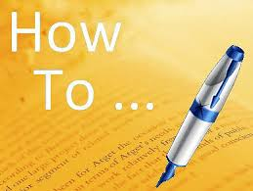
Summary
The summary presents in a condensed form the basic issues of a longer text (source). The summary provides the main points, for example, of an article or a section from a book. Syntax in a summary is complex: complete sentences; the text should be coherent, understandable, and clear.
A summary highlights only the important issues of the text, without personal judgement of the topic. Summary is absolutely objective.
Summarising
(from Trzeciak J. and Mackey S.E. Study Skills for Academic Writing. London: Prentice Hall International (UK) Ltd. 1994)
There are various types of summary you may need to make during your course.
Three main types can be distinguished:
- It may be satisfactory for your needs to summarise a text in only one or two sentences. A short summary like this may be needed, for example, for the abstract of a short essay or article you have written.
- More detailed summary may be necessary. For example, you may need to summarise the entire content of an article you are reading. This is called global summarising.
- You may need to summarise only some of the information in a text. Such a selective summary may involve only the extraction of relevant material from a large body of prose.
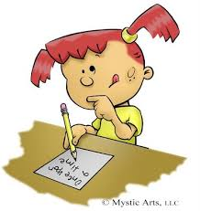
Steps in writing a summary
- Read through the whole piece carefully.
- Identify the author’s purpose; keep it
- Highlight the main point as you read.
- Make notes of your own on these points
- Begin your summary with a statement of the main idea.
- Write a sentence or two, summarizing each section of thought.
- Write a first draft of your summary, including the following items:
a) In the first sentence:1 the author’s name; 2 the article’s name; 3 the author’s thesis statement.
b) Next, your summary sentences for each paragraph or section. Put them in the order that the author presents the essay.
c) You should make every effort to put the author’s ideas into your own words to avoid plagiarism. You may occasionally quote a point directly from the author. In this case, be sure to place quotation marks and cite your page number.
- Link your section summary sentences together with good transitional words and phrases.
- Your summary should be about one third of the length of the original.
- Paraphrase the ideas as much as possible
- Avoid quotations
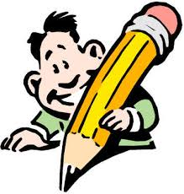REMEMBER!!!
- Reduce the information significantly!
- Remain the purpose!
- Avoid expressing your own opinion!
- Use your own words and develop your own sentences!
- Paraphrase the ideas of the original text!
Discussion
If you have an article or chapter of a book in your subject area and need to incorporate many of the ideas into an essay you are writing, which of the following strategies are you mostly likely to adopt? Discuss them with your teacher.
  - Translate the text into your own language. You can then make sure you understand it and translate relevant parts back into English (without having to look at the original) when you write an essay.
  - Having made sure you understand the English, write acknowledgement of the source of the text at the beginning of your essay. This will allow you to copy freely from text in your writing and save time and effort in having put everything into your own words.
  - Having acknowledged the source of the text, quote all the parts that are relevant to your needs in your writing. It is better to quote than to risk making mistakes by paraphrasing or summarising.
  - Read through the text, copying sentences or phrases that are relevant to your work but making sure to change some of the wording as far as possible.
  - Take notes on the text in your own words in English, having made sure you understand it. You can use your notes in writing your essay without having to consult the original text. The notes can also be used as a basis for a summary of the text if this is needed.

Characteristics of an effective summary
(from Trzeciak J. and Mackey S.E. Study Skills for Academic Writing. London: Prentice Hall International (UK) Ltd. 1994)
Discuss which characteristics below are appropriate for an effective summary
  - The same order of facts and ideas as the original
  - Similar wording to the original with occasional phrases exactly the same
  - Different sentence patterns from the original
  - additional information, which the original writer omitted but which helps an understanding of the subject
  - A personal comment on the subject
  - Simpler vocabulary than the original
  - Identification of key points to the original
